Now The Cash For Gold Is Reliable Old Gold Jewelry Buyers
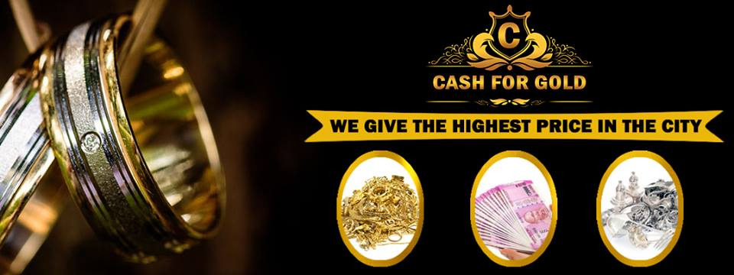
Noida, Uttar Pradesh, India, 2019-Oct-09 — /EPR Network/ — This can be normal news for you but the people who are facing the problem when they want to sell old jewelry and get disappointed or become hopeless that they are not getting a better cost for their ornaments just because they own old ornaments. It was a tough job in the market to the trading of old ornaments but now a company has solved the problem and in a way that it will never become a hassle in the way of selling jewelry at a high price.
The cash for gold Gurgaon is buying old jewelry at a high cost, yes good news that has excited the people who became hopeless and the people who are not getting better offers when they want to sell scrap at a high cost. This news had been spreading in the market in the way fire spread in the forest. Now it is attracting a large number of customers. Once again the best second-hand jewelry buyer in Delhi has surprised with this news. No one was thinking but they have done and now the leading scrap buyers are becoming the first choice. A big crowd of customers is waiting with their ornaments to be sold at an ultimate price.
The people were unaware of the fact that even the ornaments they have kept and forget are used to do any work as they can be costlier and if there is any reliable gold buyer in Noida then it will be the easiest task you have done ever. The trading of fresh articles is easy if you go to any shop or jeweler with your ornaments then you will see that how much low cost they are offering for your articles but now the best gold dealers had taken the responsibility to save all the people who have to sell gold at a high price.
The cash for gold has now reliable old gold jewelry buyers because of the customers who appreciated the cost and if it is asked a thousand times they are repeating just one name. This news was spread and the market of second-hand ornaments was stunned by hearing it but they also realized that the team of the company deserves this award as per their honest efforts in the correct direction.
About Scrap Buyers
The company pays the returns observing the current price of gold. The teams of leading scrap buyers in which most of the experts have the experience of more than ten years in the same work. This team has made the company lead the market as they had worked hard ignoring day and night to just dig out the best cost for the jewelry a customer brought to their company to sell. The procedures were made fast and as short as possible because they understand the situation of the person who came to sell jewelry for cash. Providing free services without taking any cost makes the customers happy and no deduction in returns maintains their trust in the company. The multiple methods of paying the returns are making people comfortable as it is given instantly the people get satisfied and happy. These are the reasons that made the company top jewelry buyers in the market.
Contact Information:
Goldbucks Cash for Gold
Shop No-109, first floor, P-6, Ocean Complex, Sector 18, Noida, UP – 201301 (India)
https://www.secondhandgoldbuyer.co.in/
goldbucksenterprisespvtltd@gmail.com
Tel: 9999821702, 9999821722

Press release distributed via EPR Network (http://express-press-release.net/submit-press-release.php)

