Epson Debuts New EcoTank Printers

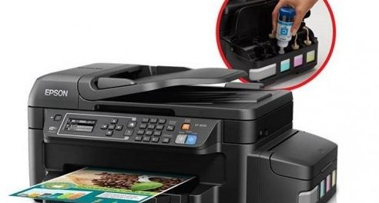

Irwindale, California, USA, 2019-Oct-11 — /EPR Network/ — Epson has released a new, cost-effective printer that is trending with the latest designs.
The printers come in 5 models. They have a brand new modern look and have won awards for their stylish white colors as well as compact properties. Furthermore, they are portable and sophisticated and redesigned for customer satisfaction. These printers, ideal for both personal use and businesses, have been on the market since April 2019.
The product overseer, Ksenia Gordeeva, verbalized her opinions and public response to these new designs. According to her statement, printers with a black finish have always been the more popular choice and the more saleable one as well. However, a number of customers requested for a design that was a bit different. They wanted a style that was classy but not abstract, something that could easily fit in whether in a stylish or professional environment. Gordeeva expressed that she believed the new smaller design, as well as the white color of the printer, was made for just that.
The Features of the EcoTank Printers
EcoTank Printers have a new design that allows space-saving capacity. The tank is placed before the printer and is no longer at its side. This new modification means that it is easier to tell if the ink is about to run-out. The Epson T200XL ink cartridges are now squeeze-free so that there wouldn’t be messes, and it is now easier to get a refill. It is also easily visible, so there can be no mistakes made since only the right colors can be inserted into their respective correct slots.
The EcoTank printer, in line with other series of printers in the cost-effective range, (series numbers L3160, L3156, L3116, L4156, L6176) all have large Epson T200XL ink cartridges filled with high-yield bottles of ink. These cartridges are included in the purchase of the printer and the Epson T200XL ink cartridges can sustain ink for 3 years, without any change to the ink’s premium quality. The Cartridge replacements are easily made and readily affordable when the ink is consumed. It allows customers to save an estimated value of 90% on ink. It is easy to print from laptops, tablets and mobile phones with EcoTank printers, with apps such as iPrint and Email Print that can be used for transferring and receiving documents between gadgets and print them as long as there is a WIFI connection.
Learn more info: https://asapinkjets.com/cic/eg/inkjetcartridge.php?cartridge=epson-t200xl120
Contact-Details:
Customer Service
ASAP Inkjets
(1) (888) 323-2727
4981 Irwindale Ave, Suite 200 CA, 91706
subscribe@asapinkjets.com
https://asapinkjets.com
Logo:
ASAP Inkjets logo
Press release distributed via EPR Network (http://express-press-release.net/submit-press-release.php)

