A New Line of Paper for Edible Ink Printing by Inkedibles

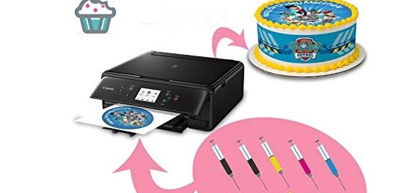
A New Line of Paper for Edible Ink Printing by Inkedibles
Irwindale, California, USA, 2019-Oct-11 — /EPR Network/ — Inkedibles has created a trustworthy brand that offers a wide range of artistic edible ink sheets – sheets for frosting, wafers and cheese. These sheets have rehydration and control of thermal properties. There are all types of sheets. All you need to do is choose the perfect type for your treat and make the order.
All Inkedible Products Are Top-notch and Hygienic
Now a popular manufacturer of edible items for the decoration of confectionary items and cakes, Inkedibles has created hygienic and top-quality edible papers including papers for edible inks, sheets for icing, edible materials for printing, and many other products. All papers are attractive and completely guaranteed safe to eat.
Frosting Sheets for Every Baker
The sheets for frosting are absolutely vital. It must be readily available in the pantry of every baker. All the sheets for frosting are manufactured with many thin layers of high quality frosting. The frosting is then pressed on top of a plastic sheet. Images are printed using the printer for edible ink papers. Many bakers use butter cream with the sheets for frosting. There are many ways this can be done, depending on the final product you hope to achieve.
There are a wide range of sheets available such as the original sheets for frosting, the premium, the artisan, the colored, the flavored, the scented, the wrappables, the FlexFrost, and the edible frosted sheet liners for cupcakes or custom cookies.
Wafer Papers for Every Treat
Apart from the frosting or icing sheets, there has been an increase in demand for edible rice papers, or wafer paper, as it is sometimes called.
The wide range of wafer papers will leave you with limitless options. You can purchase it together with a printer for edible papers, if you don’t already have one. It is much easier to print on flexibly thin and smooth wafer papers.
There are many types of designs and patterns available: leaves, butterflies and flowers. It easily dissolves when placed inside water, but in frosting, it does not dissolve, and it retains its attractive pattern and texture even when used on cakes, cupcakes or custom cookies.
All the products have attractive prices and marvelous discounts added as a bonus! Place all your orders now, from wherever you are, and begin baking deliciously attractive custom cookies, cakes, cupcakes and other treats for your business, friends or family.
For more information, visit us: https://inkedibles.com/cic/category.php?category=Custom+Printed+Iced+Cookies
Contact-Details:
Customer Service
Inkedibles
(1) 855-499-4658
4981 Irwindale Ave, Suite 200 CA, 91706
resellers@inkedibles.com
https://inkedibles.com
Logo:
Inkedibles logo
===

Press release distributed via EPR Network (http://express-press-release.net/submit-press-release.php)

