Tarps Now® Rapid Growth in Demand for Tarp Coverings by EPC Construction Contractors
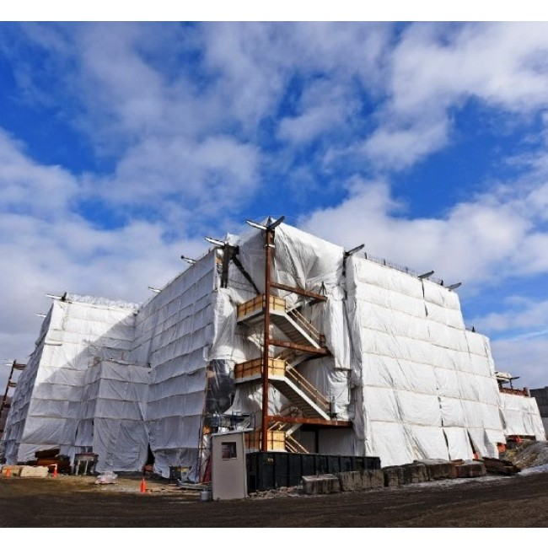
Tarps Now® Rapid Growth in Demand for Tarp Coverings by EPC Construction Contractors
St. Joseph, Michigan, United States, 2019-Oct-22 — /EPR Network/ — Tarps Now® announced significant increases in order flows by Engineering, Procurement and Construction (“EPC”) contractors throughout the North America as a result of meeting and exceeding orders for both standard sized tarps and custom tarps required in the EPC construction marketplace.
National EPC contractors have turned to Tarps Now® because of the quality, price and value offered by the firm, as well as the expedited ordering system offered on the Company’s website. EPC construction firms are actively engaged in completing turn-key projects requiring accurate cost quotes, so rapid order processing and order deliveries of tarp and covering products is critical to meet milestone events during the construction process.
In addition to facility based construction project, Tarps Now® provides a wide range of Heavy Duty Tarps and Covers engineered to meet the needs of tarps used to develop, construct and maintain a wide range of facilities serving heavy industry. Examples of industries served includes electric and gas utilities, oil and gas pipelines, retail shopping centers, multi-family community projects, and healthcare industry facility projects.
The company also provides support services to assist EPC contractors in selecting correct tarps products and coverings to meet specific application needs, as well as on-site delivery estimates as needed. Major product lines serving the EPC Construction industry are as follows:
Tarps Now® Construction Industry Tarp Covering Products Include:
https://www.tarpsnow.com/construction-tarps.html
https://www.tarpsnow.com/concrete-curing-blankets.html
https://www.tarpsnow.com/debris-scaffold-debris-netting.html
https://www.tarpsnow.com/containment-sandblasting-mesh-barrier-fr.html
https://www.tarpsnow.com/debris-lifting-tarp-snow-tarps.html
https://www.tarpsnow.com/drain-tarps-leak-diverters.html
https://www.tarpsnow.com/geotextile-mesh-screens.html
https://www.tarpsnow.com/airbag-tarps.html
https://www.tarpsnow.com/salvage-covers-and-tarps.html
https://www.tarpsnow.com/painters-drop-cloths.html
https://www.tarpsnow.com/heavy-duty-tarps.html
https://www.tarpsnow.com/heavy-duty-vinyl-tarps.html
https://www.tarpsnow.com/waterproof-canvas-tarps-breathable-tarps.html
https://www.tarpsnow.com/heavy-duty-poly-tarps.html
https://www.tarpsnow.com/heavy-duty-vinyl-mesh-tarps.html
https://www.tarpsnow.com/hypalon-tarps-csm-tarps.html
https://www.tarpsnow.com/neoprene-coated-nylon-tarps.html
https://www.tarpsnow.com/industrial-tarps.html
https://www.tarpsnow.com/industrial-covers.html
https://www.tarpsnow.com/canvas-tarps.html
https://www.tarpsnow.com/custom-fence-screen.html
About Tarps Now®
Tarps Now® features an extensive online catalog of heavy duty tarps, canvas tarps, poly tarps, custom tarps, vinyl tarps and industrial divider curtains. As specialists in custom canvas and vinyl tarps, they are the low-price leaders in their category. The company offers the convenience of fast, easy, online ordering as well as a knowledgeable staff to guide customers through the specification process insuring their project will be completed on time and in budget. Tarps Now® has the experience and scale to insure customer specifications are carefully followed and expectations exceeded for every project, large or small.
Contact-Details:
Michael Dill
Tarps Now, Inc.
4133 M-139
St Joseph, MI 49085
1-888-800-1383
sales@tarpsnow.com
www.tarpsnow.com

Logo:
Tarps Now logo

Press release distributed via EPR Network (http://express-press-release.net/submit-press-release.php)

