**Tarps Now Increases Protective Flame Retardant Tarp Fabrics for use by Homeowners**

[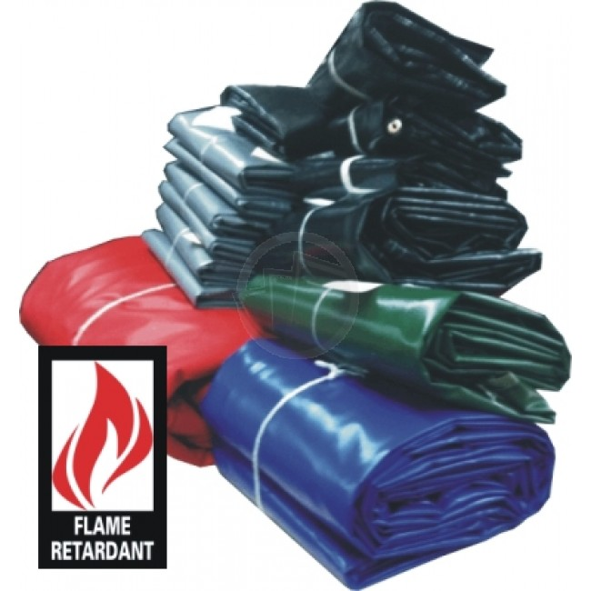](https://express-press-release.net/news/wp-content/uploads/2019/10/fireretardantvinyltarp3.jpg)

St Joseph, Michigan, United States, 2019-Oct-29 — /EPR Network/ — Noting the rapid increase in wildfires throughout California, Tarps Now® has expanded the number of protective Flame Retardant Industrial Tarp Fabrics that can be used to rapidly deploy barriers that can reduce direct contact with heated dust particles, sparks and flames that typically threaten outdoor premises and structures of all kinds. Examples include Fire Retardant Poly Tarps, Fire Resistant Mesh Tarps, Fire Retardant Vinyl Tarps, and Fire Retardant Canvas Tarps.

In addition to such flame-retardant tarp fabrics, Tarps Now® has also increased its commitment to industrial tarp fabrics that can also be used in applications where vertical installations are needed to create protective barriers. In such instances, Fire Retardant Clear Vinyl and Flame Resistant Polyethylene Sheeting can be utilized to create translucent protective screens. In all instances, industrial Flame Retardant Fabrics create extremely cost-effective barriers to the total loss of structures in the context of wildfire applications. For larger installations, the company also offers industrial grade Fire Retardant Fabric by the Yard and by the Roll.

Other time-tested flame retardant fabric solutions often used in heavy industry such as salvage covers, welding curtains or blankets which are ideal candidates for providing secondary layers of protection to reduce direct contact with heated dust, sparks and flames. These are available in a wide range of standardized sizes and colors, as well as a nearly unlimited range of custom configuration options where variations in fabric weights, sizes, coloring, and fittings are required.

**Tarps Now® Flame Retardant Fabric Options:**

<https://www.tarpsnow.com/fire-resistant-material-by-the-roll.html>  
<https://www.tarpsnow.com/poly-sheeting-flame-resistant.html>  
<https://www.tarpsnow.com/fire-resistant-tarps.html>  
<https://www.tarpsnow.com/clear-vinyl-tarps-fire-resistant-20-mil-pvc.html>  
<https://www.tarpsnow.com/fire-resistant-mesh-tarps.html>  
<https://www.tarpsnow.com/welding-screens.html>  
<https://www.tarpsnow.com/salvage-covers-and-tarps.html>  
<https://www.tarpsnow.com/fire-resistant-poly-tarps.html>  
<https://www.tarpsnow.com/fire-retardant-vinyl-tarps.html>  
<https://www.tarpsnow.com/fire-retardant-canvas-tarps.html>  
<https://www.tarpsnow.com/fire-resistant-tarps.html>

**About Tarps Now®**

Tarps Now® features an extensive online catalog of fire retardant tarps, canvas tarps, poly tarps, custom tarps, vinyl tarps and industrial divider curtains. As specialists in custom canvas and vinyl tarps, they are the low-price leaders in their category. The company offers the convenience of fast, easy, online ordering as well as a knowledgeable staff to guide customers through the specification process insuring their project will be completed on time and in budget. Tarps Now® has the experience and scale to insure customer specifications are carefully followed and expectations exceeded for every project, large or small.

**Media contact:**

Michael Dill  
Tarps Now, Inc.  
4133 M-139  
St Joseph, MI 49085  
888-800-1383  
sales@tarpsnow.com  
[https://www.tarpsnow.com](https://www.tarpsnow.com/)

Logo:

[](https://express-press-release.net/news/wp-content/uploads/2019/08/tarpsnow.jpg)

**Tarps Now logo**

Press release distributed via EPR Network (<http://express-press-release.net/submit-press-release.php>)