Wilson Dental of McLean, a Veteran-owned Business Teams Up With Soldiers’ Angels to Collect Halloween Candy for Troops and Veterans

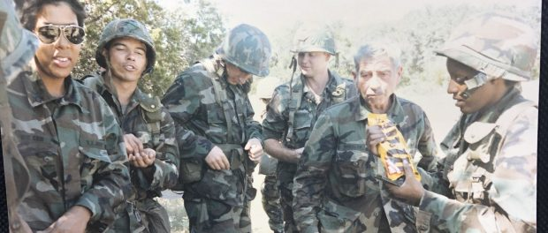
Wilson Dental of McLean is an official drop-off site for Halloween candy to benefit the Treats for Troops program hosted by national nonprofit, Soldiers’ Angels
McLean, Virginia, 2019-Oct-30 — /EPR Network/ — Every year, millions of pounds of candy end up in the trash after Halloween. From over-buying, to kids collecting more than they can eat while Trick-or-Treating, candy is wasted across the country. This year, Wilson Dental of McLean is participating in a program that will help our community produce less waste after Halloween while also showing our support for our service members and veterans! Owner, Dr. Lois Wilson, is herself a Veteran who proudly served as an Army Dentist both here and overseas.
Soldiers’ Angels, a national 501(c)3 nonprofit, hosts an annual collection drive for excess Halloween candy. The organization ships the candy to deployed service members around the world for a sweet treat from home! They also utilize their “Angel” volunteers to distribute candy to veterans of all eras in VA Hospitals across the country.
Wilson Dental of McLean is proud to team up with the national organization to get our local community involved with giving back to the brave men and women who have sacrificed so much for our country. Our business has registered with Soldiers’ Angels to be an official drop-off site for Halloween candy. Once our collection drive is over, Wilson Dental of McLean will donate all collected candy to Soldiers’ Angels where it will be packaged and shipped to deployed or distributed in VA Hospitals.
“As a veteran of the US Army, I am excited to facilitate a donation for our service men and women who are deployed or currently in the hospital. I know first hand that being away from your family during joyful holidays is extremely difficult and I hope that this small token can help bring joy to those who sacrifice so much for our country.” – Dr. Wilson
The vision of Soldiers’ Angels is: May No Soldier Go Unloved. Although the gesture of handing out miniature candy bars may seem small, the impact that small gesture can have on troops and veterans is huge.
“When you are deployed to a combat zone, there are many comfort items you may go without for an extended period of time,” says Amy Palmer, President and CEO of Soldiers’ Angels. “Receiving care packages from home is a wonderful and unexpected surprise. The joy these service members get from opening a package of treats from home is immense and has a profound impact on their morale. The same can be said for veteran patients in VA Hospitals. Some patients have no family or regular visitors. When our Angel volunteers come in with treats like candy, the spirits of these patients are immediately lifted!”
Our collection drive will run from October 25th 2019 to November 18th 2019. Please call ahead before stopping by our location to drop off your candy:
Wilson Dental of McLean
1447-C Dolley Madison Blvd
McLean Virginia 22101
For more information on the program, or if you are interested in registering your business as a drop-off site, visit: www.SoldiersAngels.org/TreatsForTroops
####
About Wilson Dental of McLean
Wilson Dental of McLean is a privately-owned cosmetic dental office located in McLean Virginia, right outside of Washington DC near Tysons Corner Mall. Dr. Wilson has served proudly in the U.S. Army Dental Corps for 7 years and has been serving the military, their families and their communities since 1985. She maintains passion and
commitment to her art and has recently been Internationally acknowledged with the Service Above Self Award for Humanitarian Dental Care in Africa.
When Dr. Wilson started Wilson Dental of McLean it became the only African American Female owned General Dentist Practice in McLean-Tysons Virginia. She has also been Locally Acknowledged and given the Trailblazer Award from the First Ladies of Dentistry for laying the pathway for future female dentist in Northern Virginia.
Learn more at www.awilsonsmile
About Soldiers’ Angels
Soldiers’ Angels is a national 501(c)(3) nonprofit that provides aid and comfort to the men and women of the United States Army, Marines, Navy, Air Force, Coast Guard, their families, and the growing veteran population. Founded in 2003 by the mother of two American soldiers, hundreds of thousands of Soldiers’ Angels “Angel” volunteers assist veterans, wounded and deployed personnel and their families in a variety of unique and effective ways. (Tax ID# 20-058-3415). Learn more at www.soldiersangels.org

Logo:
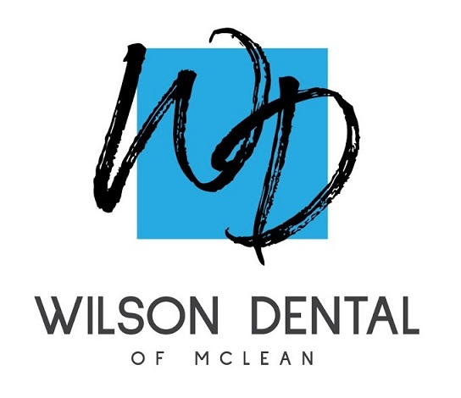
Wilson Dental of McLean logo

Press release distributed via EPR Network (http://express-press-release.net/submit-press-release.php)

