Tarps Now® Increases Available Stock to Meet Increasing Demand for Tarps
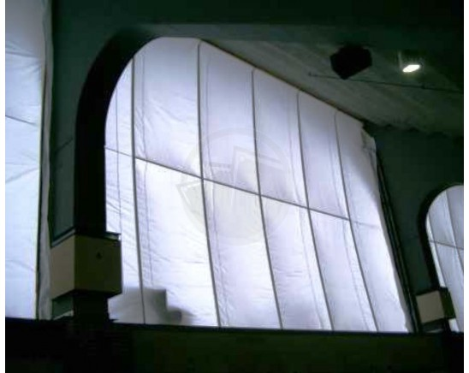
St. Joseph, Michigan, United States, 2019-Nov-05 — /EPR Network/ — Company increases availability of stock sizes tarp fabrics to meet rapid increases in demand by of governmental bodies, municipalities, businesses and residential customers
Tarps Now® is pleased to announce increased levels of available merchandising of stock sized Industrial Grade Tarps and Industrial Fabrics used by governmental bodies, businesses and residential customer in the context of disaster recovery resulting from hurricanes, storms, tornados and wildfires throughout North America and the Caribbean.
With ready access to higher grade Industrial Tarps not being available in retail stores, the advance purchases of stock sized Industrial Tarps and Industrial Fabrics greatly enhances the ability to mitigate damages and preserve assets that have not been destroyed by extended periods of heavy rainfall, storm surge, or losses related to wildfires.
To meet this need, Tarps Now® has increased its complete line of Industrial Grade Tarps and Tarp Fabric products for sale to the public, businesses, state, federal, military and other governmental agencies through their website. The company also provides online ordering of custom tarps fabricated to the specifications of its customers and delivered on site to meet the specific needs of each project or application. No other firm provides the depth and breadth of tarp products and other industrial grade fabrics specifically engineered to meet the needs of hurricane disaster recovery.
Tarps Now® Disaster Recovery Products:
https://www.tarpsnow.com/waterproof-tarps.html
https://www.tarpsnow.com/roof-debris-lifting-tarp.html
https://www.tarpsnow.com/drain-tarps-leak-diverters.html
https://www.tarpsnow.com/containment-tarps.html
https://www.tarpsnow.com/orange-barrier-fence-safety-fence-snow-fence.html
https://www.tarpsnow.com/shade-tarps.html
https://www.tarpsnow.com/construction-tarps.html
https://www.tarpsnow.com/mesh-shade-tarps.html
https://www.tarpsnow.com/7-9-oz-hurricane-trampoline-mesh-tarps.html
https://www.tarpsnow.com/nursery-landscape-tarps.html
https://www.tarpsnow.com/heavy-duty-tarps.html
https://www.tarpsnow.com/canvas-tarps.html
https://www.tarpsnow.com/mesh-tarps.html
https://www.tarpsnow.com/poly-tarps.html
https://www.tarpsnow.com/vinyl-tarps.html
https://www.tarpsnow.com/fire-resistant-tarps.html
https://www.tarpsnow.com/specialty-tarps.html
https://www.tarpsnow.com/tarp-products.html
https://www.tarpsnow.com/13-oz-vinyl-building-enclosure-tarps-fr.html
About Tarps Now®
Tarps Now® features an extensive online catalog of canvas tarps, poly tarps, custom tarps and covers, mesh tarps, vinyl tarps materials engineered to meet the needs of Hurricane recovery. As specialists in custom, canvas and vinyl tarps, they are the low-price leaders in their category, the company offers the convenience of fast, easy, online ordering, as well as a knowledgeable staff to guide customers through the specification process. Tarps Now® has the experience and scale to insure customer specifications are carefully followed and expectations exceeded.
Contact-Details:
Michael Dill, CEO
Tarps Now, Inc.
4133 M-139
St Joseph, MI 49085
888-800-1383
sales@tarpsnow.com
https://www.tarpsnow.com
Logo:
Tarps Now logo
Press release distributed via EPR Network (http://express-press-release.net/submit-press-release.php)

