New York Fire Extinguisher Service

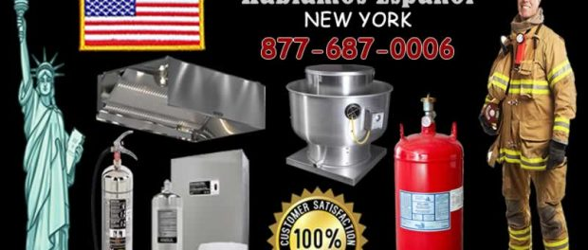
New York, NY, 2019-Nov-07 — /EPR Network/ — If you are searching for a local Fire Extinguisher Service and Sales Company providing the complete New York Metropolitan region from Brooklyn, Bronx, Queens, Staten Island, Manhattan, Long Island, Suffolk and Nassau County New York with the highest quality of fire extinguisher inspection, repair and installations across the region. As a licensed and experienced fire protection company we provide many business owners and consumers with fire life safety products. Partnering with Ansul, Buckeye, and Kidde, New York Fire Extinguisher Service is dedicated to serve the New York area with prompt and honest service.
The licensed New York company – NY Fire Extinguisher Service – is experienced enough to not just offer not just fire extinguisher equipment but complete restaurant fire prevention and ventilation solutions for the metropolitan region of NYC.
“We maintain many portable fire extinguisher and automatic fire extinguishing systems and will notify you so they never fall out of service as they must be maintained and be ready to fight any fire that arises”
NY Fire Extinguisher Service, is available for free quotes. So give them a call 877-687-0006, or email them at nyfireextinguisherservice@gmail.com for further information.
Press release distributed via EPR Network (http://express-press-release.net/submit-press-release.php)

