Tarps Now® Meets High Demand Levels from the EPC Construction Industry
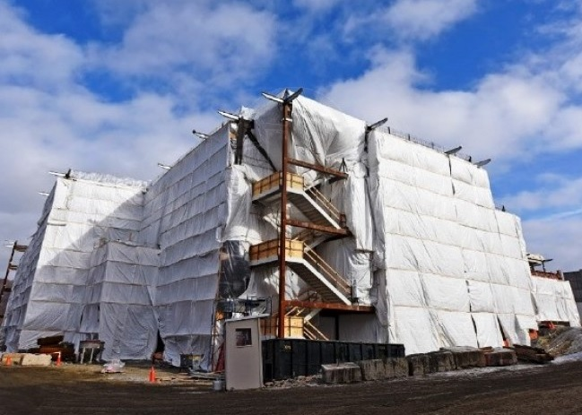
St. Joseph, Michigan, United States, 2019-Nov-20 — /EPR Network/ — Tarps Now® continues its rapid growth by and through the support of Engineering, Procurement and Construction (“EPC”) contractors requiring custom and stock sized tarp covering products and industrial fabrics to meet a wide range of construction focused needs. Of particular focus has been demand for Heavy Duty Tarps and Covers throughout the North American construction marketplace. EPC contractors are faced with demanding construction milestone schedules as well as a wide range of project related needs that require rapid processing, manufacture and delivery to construction sites throughout North America.
Tarps Now® has uniquely positioned itself to accept custom industrial tarp covering orders through its website based customization application that provides EPC contractors the means to select the desired type of industrial grade tarp covering fabric, as well as sizing, and a wide range of specifications that help contractors ensure they meet all their deliverable objectives on time and on budget when completing turn key projects.
Of particular note the EPC contractors served by Tarps Now® require accurate cost quotes and rapid order processing in order to ensure prompt order deliveries when EPC contractors are engaged in engineering, developing and constructing an increasing range of facilities serving heavy industry. Example include electric and gas utilities, oil and gas pipelines, retail shopping centers, multi-family community projects, and healthcare industry facility projects.
Tarps Now® EPC Contractor Products in High Demand:
https://www.tarpsnow.com/construction-tarps.html
https://www.tarpsnow.com/concrete-curing-blankets.html
https://www.tarpsnow.com/debris-scaffold-debris-netting.html
https://www.tarpsnow.com/containment-sandblasting-mesh-barrier-fr.html
https://www.tarpsnow.com/debris-lifting-tarp-snow-tarps.html
https://www.tarpsnow.com/drain-tarps-leak-diverters.html
https://www.tarpsnow.com/geotextile-mesh-screens.html
https://www.tarpsnow.com/airbag-tarps.html
https://www.tarpsnow.com/salvage-covers-and-tarps.html
https://www.tarpsnow.com/painters-drop-cloths.html
https://www.tarpsnow.com/heavy-duty-tarps.html
https://www.tarpsnow.com/heavy-duty-vinyl-tarps.html
https://www.tarpsnow.com/waterproof-canvas-tarps-breathable-tarps.html
https://www.tarpsnow.com/heavy-duty-poly-tarps.html
https://www.tarpsnow.com/heavy-duty-vinyl-mesh-tarps.html
https://www.tarpsnow.com/hypalon-tarps-csm-tarps.html
https://www.tarpsnow.com/neoprene-coated-nylon-tarps.html
https://www.tarpsnow.com/industrial-tarps.html
https://www.tarpsnow.com/industrial-covers.html
https://www.tarpsnow.com/canvas-tarps.html
https://www.tarpsnow.com/custom-fence-screen.html
About Tarps Now®
Tarps Now® features an extensive online catalog of heavy duty tarps, canvas tarps, poly tarps, custom tarps, vinyl tarps and industrial divider curtains. As specialists in custom canvas and vinyl tarps, they are the low-price leaders in their category. The company offers the convenience of fast, easy, online ordering as well as a knowledgeable staff to guide customers through the specification process insuring their project will be completed on time and in budget. Tarps Now® has the experience and scale to insure customer specifications are carefully followed and expectations exceeded for every project, large or small.
Media contact:
Michael Dill, CEO
Tarps Now, Inc.
4133 M-139
St Joseph, MI 49085
888-800-1383
sales@tarpsnow.com
https://www.tarpsnow.com
Logo:
Tarps Now logo
Press release distributed via EPR Network (http://express-press-release.net/submit-press-release.php)

