PrintekMobile Launches New 3” Mobile Printer

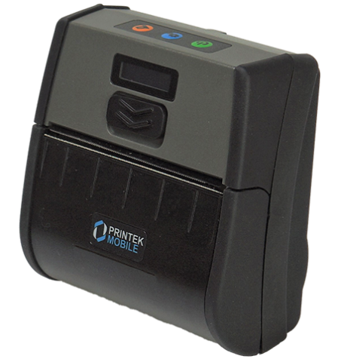
St. Joseph, Michigan, 2019-Dec-19 — /EPR Network/ — PrintekMobile, an industry leader for reliable, innovative, on-the-go rugged mobile printers, has announced the launch of its latest addition, the NEW MLP-35 3” mobile thermal printers series. The MLP-35 is an affordable mobile thermal printer for field professionals who need a lightweight, durable printer for all-day comfort. The newly designed MLP-35 allows you to quickly and easily print and tear 2 to 3-inch wide receipts, tickets, delivery notices, and more on site, saving time and money – all while improving customer service.
The MLP-35 is versatile and easy to use. The lightweight, compact design and long battery life ensures users can comfortably wear it on a belt or use a shoulder strap for an entire shift. It’s the perfect printer for a mobile work force that is always on the go with a need to print. It comes with an easy-to-read control face via its OLED screen, simple drop-in paper loading for quick paper changes, and fast print speeds up to 3 inches per seconds.
This ultra portable 3” printer allows for easy operation with just one hand. Configuring the printers is quick and easy via a web based interface that allows for a variety of setting changes on the printer. The dual tear bars provide a clear tear on all receipts and labels. The MLP-35 is an ideal printing solution for parking applications, direct store delivery, retail, hospitality, and more. Like all PrintekMobile printers, the MLP-35 is available standard with USB-C, and optional Bluetooth and Wi-Fi connectivity. A two-year bumper-to-bumper warranty provides users added assurance.
“The new MLP-35 is the perfect printer addition to the already successful line of mobile printers from PrintekMobile. The price point, feature set, and compact size of the MLP-35 makes it a great all around 3” mobile printer.” states Chris Yeager, Director of Marketing at Printek, LLC. “We’re excited to see this printer in action and provide users with an affordable mobile printing solution”.
As PrintekMobile continues to provide innovative mobile printing solutions for a variety of applications, the MLP-35 is sure to be a great addition. To download a brochure on the NEW MLP-35 printer, please visit:
https://www.printek.com/portable-mobile-printers/portable-mobile-printers-products/mlp-series-portable-printers.html
https://www.printek.com/shoulder-strap-with-carrying-case.html
https://www.printek.com/premium-receipt-paper-3-125-50-pack.html
https://www.printek.com/portable-mobile-printers/portable-mobile-printers-products/fieldpro-series.html
https://www.printek.com/portable-mobile-printers/portable-mobile-printers-products/interceptor-series.html
https://www.printek.com/portable-mobile-printers/portable-mobile-printers-products/vehiclepro-series.html
https://www.printek.com/portable-mobile-printers/portable-mobile-printers-products/lcm-series.html
https://www.printek.com/portable-mobile-printers/portable-mobile-printers-products/fp530si-series.html
About Printek, LLC
Printek’s PrintekMobile brand printers are designed to withstand challenging work environments. All Printek printers are backed by unparalleled support and comprehensive 2-yr warranties. PrintekMobile printers are direct thermal printers designed for field service, route accounting, manufacturing, retail, transportation, public safety, hospitality, warehousing and distribution applications. They print invoices, forms, receipts, tickets, labels and other documents used in mobile solutions worldwide. PrintekMobile printers also come with superior customer support – before and after the purchase. The technical sales and support staff work directly with system integrators, software developers, Value Added Resellers, and installers to develop cost-effective, innovative mobile solutions using the latest technologies. Information about Printek’s entire line of mobile printing products is available at www.printek.com.
Contact-Details:
Chris Yeager
Director of Marketing and Mobile Sales
Printek, LLC.
3515 Lakeshore Drive
St. Joseph, MI. 49085
cyeager@printek.com
800-368-4636
https://www.printek.com
Logo:
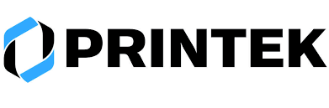
Printek logo
===
Press release distributed via EPR Network (http://express-press-release.net/submit-press-release.php)

