Wildlife Safari Vacations in Kenya Travel with Cruzeiro Safaris Kenya

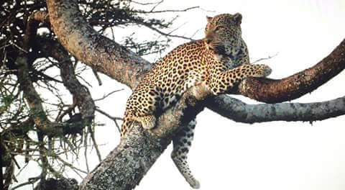
NAIROBI, Kenya, 2020-Jan-07 — /EPR Network/ — Best Year for wildlife viewing in Kenya begins with Cruzeiro Safaris Kenya
The tourism industry is anticipated to boom the year 2020 with expected tourism arrivals also expected to increase rapidly. This Boost is a godsend because tourism is one of the six economic pillars identified by the government as central in driving the economy. Kenya aims to be one of the top 10- long- haul tourist destinations in the world.
Cruzeiro Safaris Kenya is prepared to host tourists, delegates and casual travelers through providing tour operator services in Kenya. Their website is confirmed to e-commerce and guests can easily access, read details and book online for Tour within Nairobi and Mombasa as well as Road Safaris and Air Safaris.
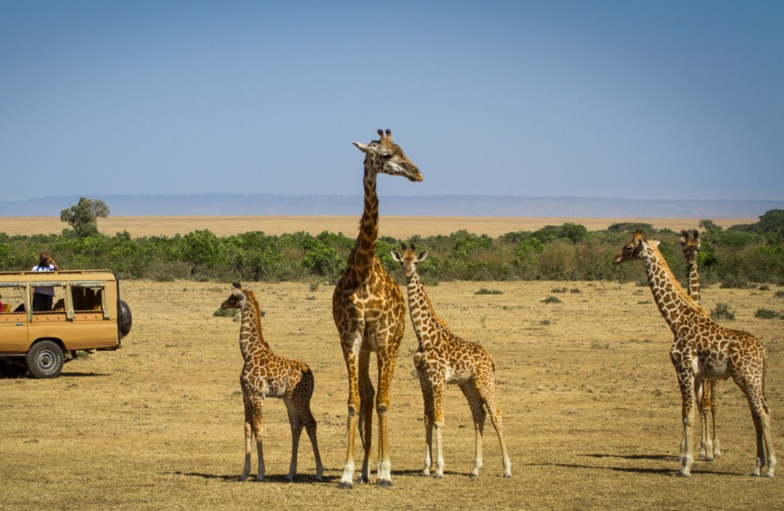
The famous Safari for 6 days to Destination Amboseli National Park, Lake Nakuru National Park and Masai Mara National Reserve with 4×4 wheel drives has gained populace within the last minute travelers especially during this season termed as the high season. The full Package details can be found on this link.
Learn more on wildlife Safari Packages and their Online Booking Partners on https://www.cruzeiro-safaris.com
Other safaris that can be booked through Cruzeiro Safaris Kenya Include:
Four (4) Days Lake Nakuru and MAsai Mara Safari
Nine(9) Days Safari from Nairobi to Mombasa
Nine(9) Days Mount Kenya and Masai Mara
Three (3) Days Masai Mara Safari by Air
Seven (7) Days Serena safaris by Air
Five (5) Days Masai Mara By Air
Two (2) Days Governors Camp Safari By Air
Three (3) Days Serena Masai Mara by Air
Seven (7) Days Singles/ Solo Travel Package by Air with Luxury Accommodation only
Three (3) Days Mara Intrepids Safari by Air
If one is searching or finding things to do in Nairobi their e-commerce site has vast information and tour packages choices https://cruzeiro-safaris.com/nairobi-tours
Follow the links for book and pay options
Option 1: 6am – 11am – Nairobi National Park Morning Tour
Option 2: 2.00pm – 6.30pm – Nairobi National Park Afternoon
Option 3: 6am – 3pm – Nairobi National Park, Elephants, Giraffe and Lunch at Carnivore
Option 4: 10am – 6.30pm – Elephants, Giraffe, Lunch at Carnivore and Nairobi National Park
Option 5; 6am- 1pm – Nairobi National Park and Elephant Orphanage
Option 6: 6am – 3pm – Nairobi National Park, Elephants and Giraffe (without lunch)
Option 7: 6am – 11am – Nairobi National Park Morning tour including park entry fees
Cost Includes:
• Game viewing drive,
• Transport pick up and drop off from hotel / Airport
• Lunch where applicable on the package
• Entry to Giraffe center with applicable package
• Entry to Elephant Orphanage with applicable package
• Safari Driver guide
Not Included in the published price are government park entry fees as follows:
– Entrance fees of US Dollars $43 per adult and USDollars $22 per child – Nairobi National Park
The above fees Are paid by strictly credit card at the point of entry on the same travel day. No cash is accepted.
About Cruzeiro Safaris Kenya
Cruzeiro-safaris.com is established in Kenya, incorporated in 2004. Its core business is safari packages and day tours complemented by air travel. It has a well-established wealth of experience in arranging memorable tours and safaris and has established a client base who provide with repeat business year after year. Join us on facebook, twitter and youtube. Safaris in Kenya may be tailored to the tourist taste and can extend to Tanzania and Uganda. Browse and read reviews on trip advisor page and one can also book from trip advisor link.
For further information and reservations, contact;
Claudia Kabui
Mobile : +254-(0) 722-370833 (Kenya)
Sales: + 254 (0) 710-729021 (Kenya)
Email: info@cruzeiro-safaris.com
Website: | https://www.cruzeiro-safaris.com and https://cruzeiro-safaris.com/nairobi-tours/
===
Press release distributed via EPR Network (http://express-press-release.net/submit-press-release.php)

