X2 FUELS MIAMI GRAFFITI SCENE FOR SUPERBOWL LIV
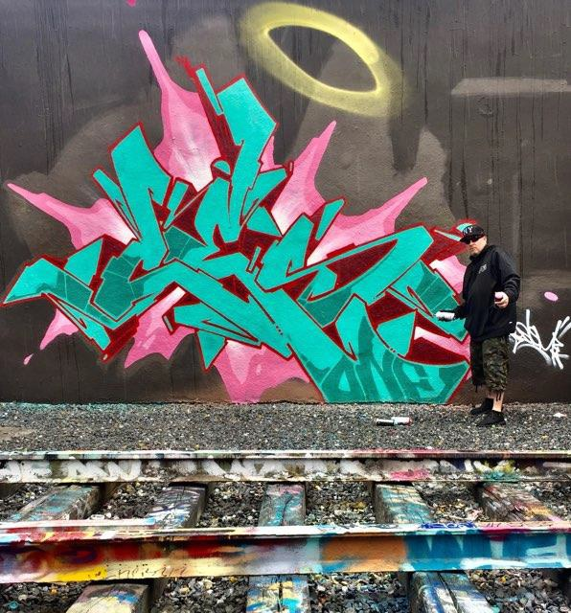
Legendary Artist CES and Emerging Sports Brand X2 disrupt Super Bowl LIV with Epic Mural
MIAMI, FL, 2020-Jan-29 — /EPR Network/ — On Friday, Jan. 31, X2 Performance® teams up with the Museum of Graffiti to commemorate Super Bowl LIV with a dynamic new mural to be unveiled by world-renowned graffiti artist CES.
X2 Performance®, a brand trusted and used by elite NFL, NBA, MLB and, NHL franchises is launching its new X2 Performance® Pre & Intra workout products now available to the general public. To celebrate Super Bowl LIV in Miami X2 Performance will host a networking breakfast that intertwines the sports industry community and the global graffiti community.
The invitation-only breakfast will be held on Friday, January 31st at 8:30 AM at the Museum of Graffiti located at 299 NW 25th St., Miami FL 33137. The event will be hosted by sports industry leaders and X2 board members Mike Tannenbaum and Mark French and principal investor L Catterton.
Guests include NFL Hall of Famers, current Pro-Bowl players, team owners, VIP’s in the sports, entertainment, and tech arenas, health and wellness influencers, and acclaimed graffiti artists.
Fans can join the #X2fuelsmiami conversations across social on Instagram (@X2Performance), Twitter (@X2Performance) and Facebook and LinkedIn (@X2Performance).
CES will live paint the mural commissioned by X2 Performance throughout the day on Wednesday, Jan 29th at 282 NW 25th Street, in Miami’s Wynwood Arts District, directly across the street from the Museum of Graffiti. Multiple camera crews will be on-site documenting this unique mural creation honoring Super Bowl LIV.
For more information on the Museum of Graffiti, visit www.museumofgraffiti.com and follow on Instagram @museumofgraffit.com.
For more information on CES, visit www.cesism.com and follow @ces4wish
###
About X2 Performance®
X2 Performance® is disrupting the sports nutrition category with a clean and effective NSF certified, patented formulation that is trusted by over 20 professional sports teams across the NBA, NFL, NHL, and MLB. X2 Performance® is rooted in science and specifically developed to maximize training and enhance competitive performance. X2 delivers endurance naturally through its unique X2 Performance® powder and ready to drink products that utilize a patented formula with no artificial ingredients, is low in sugar, and uses antioxidant-rich green tea to deliver sustained energy without adverse side effects like jitters or a hard crash. X2 products are available in Subway® restaurants, online at Amazon and www.x2performance.com.
About CES
Born Robert Michael Provenzano in 1970, CES, also known as Wish, is one of the true OG’s of graffiti. He is a New York City leader of the streamlined and aerodynamic “Wildstyle,” alphabetic reconfiguration in contemporary graffiti, and widely known for his amazing graffiti sneaker art that incorporates silhouettes with modern graffiti style. He has done pieces based on classic Air Jordan kicks, Nike Air MAX 1sp “Moon Landing” and the Nike LeBron XI “Parachute Gold.” His innovations have influenced an entire generation of graffiti writers in the United States and abroad. Besides New York, he has done work in cities as varied as Athens, Boston, Basel, Tokyo, Amsterdam, and Berlin.
About the Museum of Graffiti
Located in Miami’s Wynwood District, the Museum of Graffiti is the first contemporary art museum dedicated to sharing the power of expression, sparking wonder, and inspiring creativity for and about the graffiti art movement. At the Museum of Graffiti, visitors can explore the history of graffiti in an experiential setting with interactive exhibitions and unique shows. The Museum seeks to honor and preserve the unique art form and to exhibit important works for permanent viewing. Through changing exhibitions and programs, the Museum aims to introduce visitors to the artists, paintings, photos, sculptures, works on paper, and designs that have captivated youth and adults for over fifty years, as well as the environment in which the global art movement was formed.
Media Contact
Cece Feinberg
+1 305-951-3494
cece@feinbergpr.com

Press release distributed via EPR Network (http://express-press-release.net/submit-press-release.php)

