Tarps Now Accepts Requests for Proposals from EPC Construction Industry Contractors
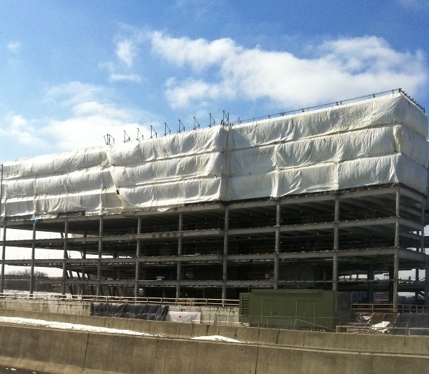
St. Joseph, Michigan, USA, 2020-Jan-30 — /EPR Network/ — Tarps Now® is pleased to announce increased commitment to Construction Industry by inviting Requests for Proposals (“RFP”) requests from firms engaged in providing turn-key Engineering, Construction and Procurement (“EPC”) bids involving industrial grade tarp and covering products used to develop, construct, maintain and operate a wide range of facilities serving heavy industry, electric and gas utilities, oil and gas pipelines, retail shopping centers, multi-family community projects, and healthcare facility projects.
Specific to such RFP requests, Tarps Now® provides EPC contractors options to select from a complete range of standard sized, industrial grade Heavy Duty Tarps, or in the alternative, Tarps Now® provides a custom tarps and coverings application within its website which allows contractors the means to select the specifications to cover large installations such as building façades, cooling towers, back-up power generators, heavy equipment and site management coverings of all types.
To meet the demands of EPC contractors, Tarps Now® has expanded the number of lines of heavy tarps and coverings engineered to meet the needs of contractors throughout the construction marketplace. The Company is actively engaged in supporting sizeable turn-key projects requiring accurate cost quotes, rapid order processing and order deliveries of industrial grade tarps and covers throughout North America.
Tarps Now® EPC Contractor Focused Industrial Tarp Coverings Include:
https://www.tarpsnow.com/construction-tarps.html
https://www.tarpsnow.com/concrete-curing-blankets.html
https://www.tarpsnow.com/debris-scaffold-debris-netting.html
https://www.tarpsnow.com/containment-sandblasting-mesh-barrier-fr.html
https://www.tarpsnow.com/debris-lifting-tarp-snow-tarps.html
https://www.tarpsnow.com/drain-tarps-leak-diverters.html
https://www.tarpsnow.com/geotextile-mesh-screens.html
https://www.tarpsnow.com/airbag-tarps.html
https://www.tarpsnow.com/salvage-covers-and-tarps.html
https://www.tarpsnow.com/painters-drop-cloths.html
https://www.tarpsnow.com/heavy-duty-tarps.html
https://www.tarpsnow.com/heavy-duty-vinyl-tarps.html
https://www.tarpsnow.com/waterproof-canvas-tarps-breathable-tarps.html
https://www.tarpsnow.com/heavy-duty-poly-tarps.html
https://www.tarpsnow.com/heavy-duty-vinyl-mesh-tarps.html
https://www.tarpsnow.com/hypalon-tarps-csm-tarps.html
https://www.tarpsnow.com/neoprene-coated-nylon-tarps.html
https://www.tarpsnow.com/industrial-tarps.html
https://www.tarpsnow.com/industrial-covers.html
https://www.tarpsnow.com/canvas-tarps.html
https://www.tarpsnow.com/custom-fence-screen.html
About Tarps Now®
Tarps Now® features an extensive online catalog of heavy duty tarps, canvas tarps, poly tarps, custom tarps, vinyl tarps and industrial divider curtains. As specialists in custom canvas and vinyl tarps, they are the low-price leaders in their category. The company offers the convenience of fast, easy, online ordering as well as a knowledgeable staff to guide customers through the specification process insuring their project will be completed on time and in budget. Tarps Now® has the experience and scale to insure customer specifications are carefully followed and expectations exceeded for every project, large or small.
Media contact:
Michael Dill
Tarps Now, Inc.
4133 M-139
St Joseph, MI 49085
888-800-1383
sales@tarpsnow.com
https://www.tarpsnow.com
Logo:
Tarps Now® logo
===
Press release distributed via EPR Network (http://express-press-release.net/submit-press-release.php)

