Author Announces Latest Thriller Novel
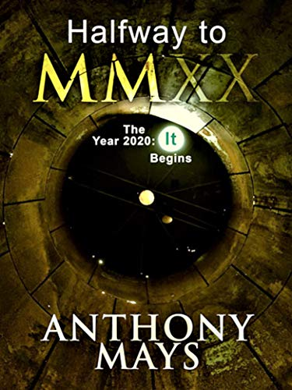
Belleville, IL, 2020-Feb-29 —/EPR Network/ — Recently released Halfway to MMXX The Year 2020: It Begins, is available in the Amazon bookstore. This latest release promises to be the thriller everyone will be talking about in 2020. While a work of fiction, he believes climate change is preparing the Arctic to become the next great economic battleground.
A professor and climatologist are hot on the trail of a mystery surrounding a monk’s predictions from the year 1010. Old documents, discovered at Fleury Abbey in France, point to a potential disaster beginning in 2020.
Meanwhile, world-wide seismology sensors are picking up unusual tremors in the Arctic’s Pechengsky District. The Russians are telling everyone the quakes are the result of mining operations. Two female, earth sciences phenoms are separately tracking Russia’s activity and their suspicions lead them to seek help from the truth seekers.
It isn’t long before they discover events in the Russian Arctic and the prognostications of the monk are closely linked. Five unlikely acquaintances bring their unique understanding of science, history, and religion to combat the forces of nature. Will their efforts prove too late to stop the foretold beginning of the end?
This novel has been accorded the LiFE (Literature for Environment) Award. http://bobswriting.com/life.html
About the Author
The author is an independently published writer of fictional novels and short stories. He has taken pieces of his life experiences and molded them into fictional works of art. Get more information at http://www.halfwayauthor.com.
Media contact:
Anthony Mays
HalfwayAuthor
2209 Monterey Drive,
Belleville, IL
62221,618-606-5927
halfwayauthor@yahoo.com
www.halfwayauthor.com
===
Press release distributed via EPR Network (http://express-press-release.net/submit-press-release.php)

