Tarps Now Expands Offerings of Industrial Grade Tarps & Covers throughout North America

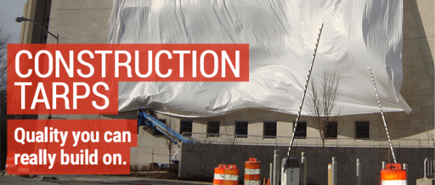
St. Joseph,Michigan, USA, 2020-Mar-13 — /EPR Network/ — Tarps Now® is pleased to announce the expansion of it’s offering of industrial grade Heavy Duty Tarps used by construction contractors, manufacturers, trucking companies and a wide range of service industries throughout North America. Due to extraordinary sales growth among these customer groups, Tarps Now® undertook expansion of its industrial grade segment in order to meet ever increasing levels of demand. By example, contractors developing electric and gas utilities projects, oil and gas pipelines, retail shopping centers, multi-family community projects and healthcare industry facility projects.
In addition to the above merchandising expansion, Tarps Now® is meeting ever increasing demand for custom tarps and covers used to protect manufacturing machinery to sizes as large as electric utility cooling towers. Tarps Now® leads the industrial fabrics industry with technologies that are utilized to rapidly process tarps in a wide range of sizes, colors, fabrics and weights, as well as custom fittings engineered to meet even the most rigorous of demands. Custom made industrial tarps are often selected when stock sizes of canvas tarps will not meet the specifications of an individual project, or long-term client needs.
Supporting the vast array of industrial grade options available to clients, Tarps Now® is staffed by a very well-trained team of industry professionals equipped to meet customer service needs at every juncture. Customer ratings and reviews tell the tale, as Tarps Now® has the highest ratings found in the online industrial fabrics sector.
Tarps Now® Stock and Custom Tarp Covering Offerings Include:
https://www.tarpsnow.com/heavy-duty-tarps.html
https://www.tarpsnow.com/custom-tarps-covers.html
https://www.tarpsnow.com/heavy-duty-vinyl-tarps.html
https://www.tarpsnow.com/mesh-tarps.html
https://www.tarpsnow.com/waterproof-canvas-tarps-breathable-tarps.html
https://www.tarpsnow.com/heavy-duty-poly-tarps.html
https://www.tarpsnow.com/heavy-duty-vinyl-mesh-tarps.html
https://www.tarpsnow.com/hypalon-tarps-csm-tarps.html
https://www.tarpsnow.com/neoprene-coated-nylon-tarps.html
https://www.tarpsnow.com/industrial-tarps.html
https://www.tarpsnow.com/industrial-covers.html
https://www.tarpsnow.com/canvas-tarps.html
About Tarps Now®
Tarps Now® features an extensive online catalog of heavy duty tarps, canvas tarps, poly tarps, custom tarps, vinyl tarps and industrial divider curtains. As specialists in custom canvas and vinyl tarps, they are the low-price leaders in their category. The company offers the convenience of fast, easy, online ordering as well as a knowledgeable staff to guide customers through the specification process insuring their project will be completed on time and in budget. Tarps Now® has the experience and scale to insure customer specifications are carefully followed and expectations exceeded for every project, large or small.
Media contact:
Michael Dill, CEO
Tarps Now, Inc.
4133 M-139
St Joseph, MI 49085
888-800-1383
sales@tarpsnow.com
https://www.tarpsnow.com
Logo:
Tarps Now® logo
Press release distributed via EPR Network (http://express-press-release.net/submit-press-release.php)

