Demand for Tarps and Plastic Sheeting Materials Remains Strong during COVID-19 Outbreak
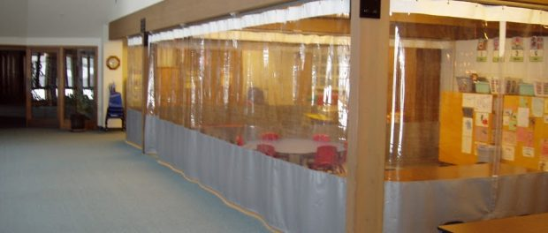
St. Joseph, Michigan, United States, 2020-Mar-27 — /EPR Network/ — Tarps Now® is meeting unexpected demand for tarps and plastic sheeting materials during COVID-19 Outbreak
Tarps Now® is pleased to announce continuing demand for tarps and plastic sheeting materials sought by retail, wholesale and industrial customers in the wake of the COVID-19 virus outbreak. Once factor for the demand for tarps and plastic sheeting materials include ready access to specialty tarps rarely available in “big box” retail stores, which includes highly specialized products and other industrial grade fabrics specifically engineered to meet the needs of businesses, state, federal, military, and other governmental agencies.
Other factors driving demand includes the Canvas Tarps and other Premium Grade Cotton Canvas Duck Fabrics which are breathable and waterproof, as well as very durable. Crafted with superior stitching, double-folded hems, and sturdy brass grommets for proper tie-downs, this type of Industrial Grade Canvas Tarps are available in a wide range of standard sizes fitted with various grades, colors and weights, as well as a selection of distinct material refinements such as treated, untreated, natural and fire-retardant fabric treatment options.
As a result of continuing rapid growth of the Canvas Tarps division, Tarps Now® offers the widest selection of standardized plastic sheeting products found in the entire tarps industry. In addition, Tarps Now® also offers custom fabrication options to the exact specifications sought by its customers using a custom configuration application for on the TarpsNow.com website.
Tarps Now® High Demand Products:
https://www.tarpsnow.com/heavy-duty-tarps.html
https://www.tarpsnow.com/construction-tarps.html
https://www.tarpsnow.com/industrial-tarps.html
https://www.tarpsnow.com/heavy-duty-vinyl-tarps.html
https://www.tarpsnow.com/canvas-tarps.html
https://www.tarpsnow.com/heavy-duty-poly-tarps.html
https://www.tarpsnow.com/heavy-duty-vinyl-mesh-tarps.html
https://www.tarpsnow.com/hypalon-tarps-csm-tarps.html
https://www.tarpsnow.com/neoprene-coated-nylon-tarps.html
https://www.tarpsnow.com/waterproof-tarps.html
https://www.tarpsnow.com/industrial-covers.html
https://www.tarpsnow.com/truck-tarps.html
https://www.tarpsnow.com/airbag-tarps.html
About Tarps Now®
Tarps Now® features an extensive online catalog of canvas tarps, poly tarps, custom tarps and covers, mesh tarps, vinyl tarps materials engineered to meet the needs of Hurricane recovery. As specialists in custom, canvas and vinyl tarps, they are the low-price leaders in their category, the company offers the convenience of fast, easy, online ordering, as well as a knowledgeable staff to guide customers through the specification process. Tarps Now® has the experience and scale to insure customer specifications are carefully followed and expectations exceeded.
Contact-Details:
Michael Dill, CEO
Tarps Now, Inc.
4133 M-139
St Joseph, MI 49085
888-800-1383
sales@tarpsnow.com
https://www.tarpsnow.com
Logo:

Tarps Now® logo
Press release distributed via EPR Network (http://express-press-release.net/submit-press-release.php)

