Nationwide Stay at Home Orders Sparks the Ingenuity of DIY Consumers

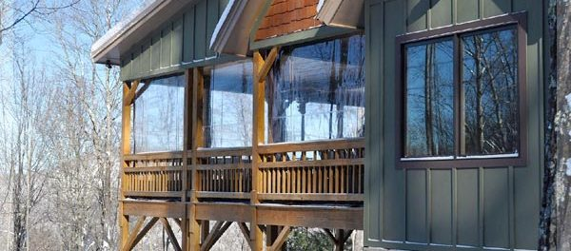
St Joseph, MI, USA, 2020-Apr-15 — /EPR Network/ — Tarps Now® is pleased to announce strong nationwide orders specific to a wide range of home and farm based Do-It-Yourself (“DIY”) projects such as awnings and overhead vehicle covers, screens and covers for outdoor work and play areas, building structure upgrades, as well as garden, yard landscaping and greenhouse projects.
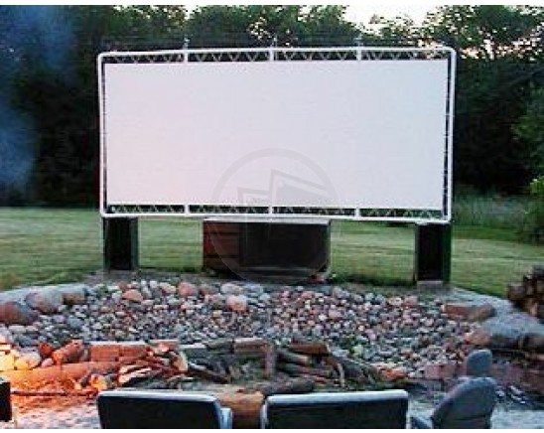
Awnings and Overhead Vehicle Coverings: To increase the effectiveness and lifespan of your equipment, machines, cars, truck, and other vehicles that are not in use, many consumers are using stay at home time by covering driveway areas with Awning fabrics, or in some cases, Heavy Duty Tarps. Whether adjacent a garage, breezeway, walk out basement, or even outside over outdoor Gazebos; consumers are using coverings that provide future protection against the damaging effects of rain, snow, wind, wildlife, dust, dirt, and other contaminants. Consumers are also often selecting Canvas, Vinyl and Poly materials for these projects.
Outdoor Work, Play, Pet and Livestock Areas: Space around houses, patios, barbeque areas, swimming pools, outdoor kennels, barns, garages and outbuildings that need shade and protection from the elements have been consumer favorites. Placing tarps and fabrics strategically as covers, screens or as curtains in open areas of structures brings many benefits to these areas zones. Fabrics most often selected includes: Vinyl, Clear Vinyl, and Mesh Tarp Covering Materials.
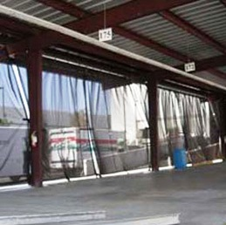
Building Structure Upgrades: Tarps are a great way to guard against spill, spray, and damage to the inside or outside of your structures as a result from nearby work, repairs, and weather. Easily securing a tarp protects these structures. Roofing Tarps are an extremely valuable tool after roof damage or during construction or repairs. Material being used most often includes Poly and Vinyl.
Garden, Yard Landscaping and Greenhouse Projects: Tarp covers and fabrics are being used in a number of lawn care and landscaping applications including catching branch and bush trimmings along with hauling lawn waste and other items that need to be carried. A number of specialty tarps such as debris lifting tarps and snow tarps allow you to lift debris and supplies off areas such as roofs or effectively remove fresh snow from jobsites. Clear plastics are frequently being used to repair green houses, Tarp materials most often selected includes Clear PVC Vinyl, Poly, Mesh and Debris Lifting Tarps.
Tarps Now® DIY Tarps, Covers and Materials Most Often Used by Consumers:
https://www.tarpsnow.com/awning-marine-canvas-tarps.html
https://www.tarpsnow.com/awning-canopy-vinyl-tarps.html
https://www.tarpsnow.com/mesh-curtains.html
https://www.tarpsnow.com/outdoor-movie-screen-tarp.html
https://www.tarpsnow.com/clear-vinyl-porch-curtains.html
https://www.tarpsnow.com/roof-debris-lifting-tarps.html
https://www.tarpsnow.com/nursery-landscape-tarps.html
https://www.tarpsnow.com/debris-lifting-tarp-snow-tarps.html
https://www.tarpsnow.com/artic-rink-liners.html
https://www.tarpsnow.com/sports-tarps.html
https://www.tarpsnow.com/92-privacy-fence-screen-10-0-x-150-0-roll.html
https://www.tarpsnow.com/88-privacy-fence-screening-7-8-x-150-0-roll.html
https://www.tarpsnow.com/heavy-duty-tarps.html
https://www.tarpsnow.com/custom-tarps-covers.html
https://www.tarpsnow.com/canvas-tarps.html
https://www.tarpsnow.com/mesh-tarps.html
https://www.tarpsnow.com/poly-tarps.html
https://www.tarpsnow.com/vinyl-tarps.html
https://www.tarpsnow.com/fire-resistant-tarps.html
https://www.tarpsnow.com/industrial-tarps.html
About Tarps Now®
Tarps Now® features an extensive online catalog of heavy duty tarps,canvas tarps, poly tarps, custom tarps, vinyl tarps and industrial divider curtains. As specialists in custom canvas and vinyl tarps, they are the low-price leaders in their category. The company offers the convenience of fast, easy, online ordering as well as a knowledgeable staff to guide customers through the specification process insuring their project will be completed on time and in budget. Tarps Now® has the experience and scale to insure customer specifications are carefully followed and expectations exceeded for every project, large or small.
Media contact:
Michael Dill, CEO
Tarps Now, Inc.
4133 M-139
St Joseph, MI 49085
888-800-1383
sales@tarpsnow.com
https://www.tarpsnow.com
Logo:
Tarps Now® logo
===

Press release distributed via EPR Network (http://express-press-release.net/submit-press-release.php)

