Accents Inserts Have Been Found to Remove Sweat Bacteria from Shoes

Emeryville, CA, U.S.A., 2020-Apr-29 — /EPR Network/ — Accents Inserts have been found to remove sweat bacteria from shoes. This buildup creates odor that is then spread onto shoes and feet. These insoles extract this accumulation from the soles of shoes preventing continued growth of bacteria. It is unhygienic when people continue reusing their shoes barefoot. Removing the sweat that holds the bacteria causing the smell is beneficial to ending this issue. Accents Inserts are patented replaceable shoe liners acting as a barrier designed to help people overcome their concern with having bacteria buildup and odor in their shoes.
Rachele Cazarez, Founder and CEO, expresses that, “This product will answer several issues we all face while going about our daily routines.” She points out that, “We all deal with the problems of sweat, bacteria and odor buildup in our shoes. Sweat also causes our feet to slide around in shoes and even squeak when we walk.” She goes on to state that, “These all cause discomfort and embarrassment.” She wants it noted that her invention has been designed with care and assembled with quality materials to combat growth of sweat, bacteria and odor in shoes.
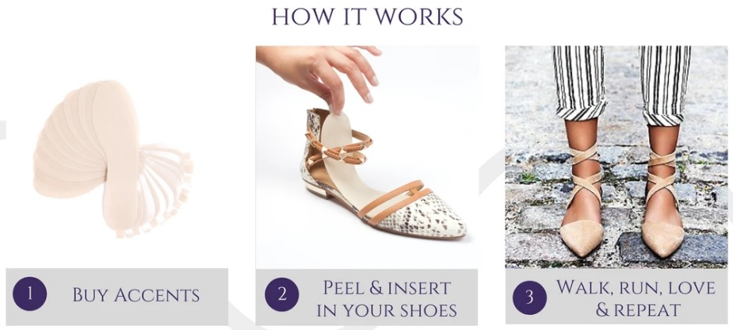
The facts show that there are 250,000 sweat glands in the average pair of feet. These cause feet to excrete a half-pint of sweat per day. This then leads to bacteria and odor that increase in a shoe and multiply with each use. Having a barrier like Accents Inserts absorb these, which are then disposed of and replaced with a fresh pair, has been found to be a welcome answer to stopping this accumulation. Continued replacement of the shoe liners makes it feel like a clean new pair of shoes each time they are worn. Accents Inserts are leading people to look at a better answer to an age-old problem that affects everybody.
To learn more about Accents Inserts, click here: https://www.accentsinserts.com
They are available on Amazon at: https://www.amazon.com/accentsinserts
About Accents Inserts:
Accents inserts is a Hispanic woman owned and operated company that is focused on creating great quality shoe liners. Their patented technology offers a unique solution that stands out from others on the market. The company believes that everyone deserves to strut through life in comfort.

Press release distributed via EPR Network (http://express-press-release.net/submit-press-release.php)

