Company Delivers Partitions Enhancing Social Distancing in the Workplace

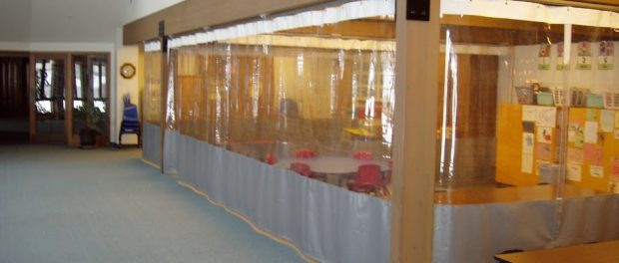
St. Joseph, Michigan, USA, 2020-May-06 — /EPR Network/ — Tarps Now® meets high demand for Translucent Partitions, Clear Clean Room Curtains and Plastic Sheeting Materials used to for Social Distancing.
Tarps Now® is pleased to announce continuing demand for clear plastic partitions, clean room curtains and plastic sheeting materials sought by companies to maximize social distancing in the workplace. These materials help to minimize transmission of viral aerosols and other forms of airborne contaminants used in a variety of different type of work areas and industries.
Often these materials are suspended from workplace ceilings, which makes them easy to install and extremely flexible. Curtains most often selected are made of heavy duty industrial grade Clear PVC vinyl, which is California Fire Marshal approved. These help reduce the threat of direct viral transmissions, all while resisting the ill effects of dirt, dust, mildew, moisture, oil, grease and many chemicals.
Other applications include the use of clean room panels which are hung using 304 stainless steel tracking and attachments that allow for a high degree of customization for almost any work environment, helping to mitigate the transmission of germs, viruses, dust, moisture, chemicals and other harmful contaminants.
With the increased focus on social distancing in the workplace, Tarps Now® is meeting the needs of a wide variety of organization with its selection of plastic sheeting solutions. In addition, Tarps Now® also offers custom fabrication options to the exact specifications of any given work area using a custom configuration application for on the TarpsNow.com website.
Products Supporting Social Distancing:
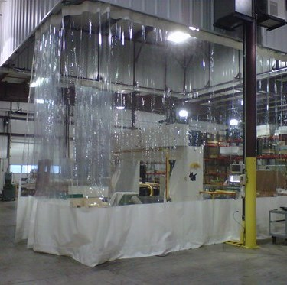
https://www.tarpsnow.com/clean-room-curtains.html
https://www.tarpsnow.com/clear-vinyl-curtains.html
https://www.tarpsnow.com/food-processing-curtains.html
https://www.tarpsnow.com/wash-bay-curtains.html
https://www.tarpsnow.com/room-divider-curtains.html
https://www.tarpsnow.com/divider-curtain-tracks-hardware.html
https://www.tarpsnow.com/clear-vinyl-strip-doors.html
https://www.tarpsnow.com/industrial-divider-curtains.html
https://www.tarpsnow.com/custom-made-industrial-curtains.html
About Tarps Now®
Tarps Now® features an extensive online catalog of canvas tarps, poly tarps, custom tarps and covers, mesh tarps, vinyl tarps materials engineered to meet the needs of Hurricane recovery. As specialists in custom, canvas and vinyl tarps, they are the low-price leaders in their category, the company offers the convenience of fast, easy, online ordering, as well as a knowledgeable staff to guide customers through the specification process. Tarps Now® has the experience and scale to insure customer specifications are carefully followed and expectations exceeded.
Media contact:
Michael Dill, CEO
Tarps Now, Inc.
4133 M-139
St Joseph, MI 49085
888-800-1383
sales@tarpsnow.com
www.tarpsnow.com
Logo:
Tarps Now® logo
===
Press release distributed via EPR Network (http://express-press-release.net/submit-press-release.php)

