Consumers using Clear Vinyl and Poly Sheeting for DIY Covid-19 Protection

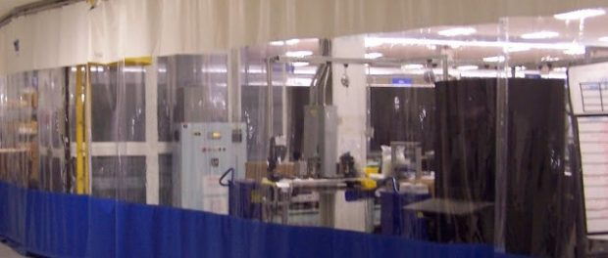
Company Provides Products used to improve Social Distancing in the Workplace
St. Joseph, Michigan, USA, 2020-May-19 — /EPR Network/ — With limited openings occurring in several states, consumers are utilizing Clear Vinyl Fabrics and Poly Sheeting to crate barriers and improve the safety of customers, employees and students to reduce approximately and improve social distancing. In particular, Clear Vinyl is being utilized to help create protective barriers that aid in reducing the spread of airborne virus transmission and other forms of contamination. In particular, Clear Vinyl is a waterproof materials that easy to clean and sanitize, yet durable enough to provide many years of service.
Tarps Now® offers a number of clear vinyl strip curtains often used in clean rooms, food processing and other applications that reduces the risk of airborne contaminants in businesses such as food processing plants, restaurants, nursing homes, hospitals and schools. Mixed uses of mat Clear Vinyl, Clear Vinyl Curtains and Clear Vinyl Fabrics are sold by the Yard or Roll in an assortment of sizes, grades and thicknesses, as well as hardware to install these materials.
In addition to the installation of clear vinyl barriers, front line workers including nurses, doctors, technicians, police, EMT’s, fire fighters and grocery workers have been early adopters of Do-It-Yourself (“DIY”) Vinyl Safety Products. No specialized materials are required for DIY fabrication. The main material needed is clear plastic or clear vinyl which is readily available in many forms, including sheets and rolls. By example, clear vinyl DIY Face Shields are being created to provide a clear plastic barrier that covers the face with no exposed gap with the headpiece and the forehead. Optimally, the shields extend from the forehead to below the chin while reaching laterally across to the ears.
Recently, the Journal of the American Medical Association (JAMA) published an article on the many advantages of clear plastic face covers including being able to be used indefinitely, being cleaned with soap and water or household disinfectants. DIY Face Shields are safe, easy, and comfortable to wear while greatly protecting the vital viral portal entries (mouth, nose and eyes), typically reducing immediate viral exposure by 96 percent. Face shields also prevent the wearers from touching their own faces, which is a frequent source of viral infection.
Products Supporting DIY Covid-19 Virus Protection
https://www.tarpsnow.com/poly-sheeting-flame-resistant.html
https://www.tarpsnow.com/clean-room-curtains.html
https://www.tarpsnow.com/clear-vinyl-curtains.html
https://www.tarpsnow.com/food-processing-curtains.html
https://www.tarpsnow.com/wash-bay-curtains.html
https://www.tarpsnow.com/room-divider-curtains.html
https://www.tarpsnow.com/divider-curtain-tracks-hardware.html
https://www.tarpsnow.com/clear-vinyl-strip-doors.html
https://www.tarpsnow.com/industrial-divider-curtains.html
https://www.tarpsnow.com/custom-made-industrial-curtains.html
https://www.tarpsnow.com/divider-curtain-curtain-walls.html
About Tarps Now®
Tarps Now® features an extensive online catalog of plastic and vinyl sheeting, as well as canvas tarps, poly tarps, custom tarps, vinyl tarps and industrial divider curtains. As specialists in custom canvas and vinyl tarps, Tarps Now® is the low-price leader in their category. The company offers the convenience of fast, easy, online ordering, as well as a knowledgeable staff to guide customers through the specification process ensuring each project will be completed on time and in budget. Tarps Now® has the experience and scale to meet customer specifications and expectations exceeded for every project, large or small.
Media contact:
Michael Dill, CEO
Tarps Now, Inc.
4133 M-139
St Joseph, MI 49085
888-800-1383
sales@tarpsnow.com
www.tarpsnow.com
Logo:
Tarps Now® logo
===
Press release distributed via EPR Network (http://express-press-release.net/submit-press-release.php)

