Never pay Security alarm monitoring fees again!

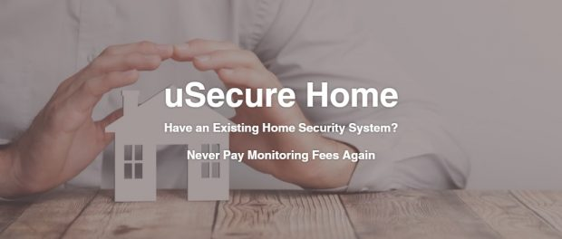
Jacksonville, FL, 2020-May-19 — /EPR Network/ — uSecureProp, LLC’s, uSecurehome/biz device, enables existing home/biz security systems to be easily converted to self-monitoring and never having to pay monthly monitoring fees again! Also for home owners who have an installed system but do not have a monitoring service.
Owners receive an alarm call, text and email with roll-over to back-up numbers and police, identical to the typical monitoring services.
Go to www.uSecurehome.com for additional information
Contact-Details: Robert van Winkel

Press release distributed via EPR Network (http://express-press-release.net/submit-press-release.php)

