USBLockit.com releases Free App to “Password Protect the USB Flash Drive” for Android

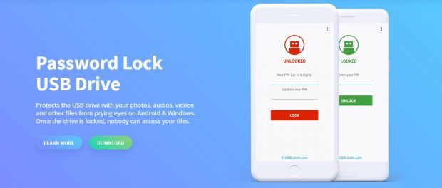
USBLockit.com has released the World’s First App to Password Protect the USB Flash Drive for Android users on Google Play Store.
PADOVA, Italy, 2020-Jun-03 — /EPR Network/ — USBLockit.com has released a powerful security app for Android users on Google Play Store called ‘USB Lockit’. The app allows you to password protect the USB flash drive keeping it safe from unauthorized access.
This application enables you to set a pin-code protection to your USB flash drive. Once this has been done, the drive is effectively locked until the correct pin is entered. Once the drive is locked, one cannot read no write to it without the correct pin.
With this software, all your photos, audio, videos and other files stored on a FAT32/exFAT formatted USB flash drive can be easily protected from prying eyes. When you lock the drive, unauthorized access is prevented in all Operating Systems.
“We are happy to announce the new app release which is user-friendly and protects the USB flash drive with the private files effectively. The fact that the software is available for Windows and Android means that it is ideal for anyone who works with PC or Smartphone”, says Nicola Bezze, CEO of USBLockit.com
Compatible with your Android phones, Install USB Lockit from Google Play Store and password protect your USB flash drive:
https://play.google.com/store/apps/details?id=com.usblockit.app
About:
USBLockit.com offers users a friendly yet extremely powerful security software to protects the private files stored on USB flash drive. It has a large user-base in Europa followed by several countries in America and Asia. For more information, please visit www.usblockit.com
Media contact:
USBLockit.com
contact@usblockit.com

Press release distributed via EPR Network (http://express-press-release.net/submit-press-release.php)

