Tarps Now Announces Joins Fight Against COVID-19 as Response Supplier

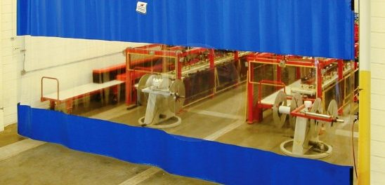Industrial Curtains - Combination Blue with Clear Window Panel
St. Joseph, Michigan, USA, 2020-Jun-12 — /EPR Network/ — Firm expands efforts against Coronavirus Pandemic as Validated Thomas COVID-19 Response Supplier
Tarps Now® is pleased to announce it has joined Thomas for Industry in its efforts to mobilize manufacturers and fulfill demand for critical products and services fighting the COVID-19 crisis. As a validated COVID-19 Supplier, Tarps Now® is helping to mobilize and provide availability of plastic and vinyl sheeting products and materials used to protect of essential workers with protective materials and barriers that help mitigate Coronavirus transmission.
Evidencing the beneficial use of barriers in the fight against the spread of COVID-19, the Journal of the American Medical Association recently published an article detailing the many advantages of clear plastic face covers. The benefits discussed included being able to use clear plastic nearly indefinitely, easily disinfected, with protection viral portal entry in areas such as the mouth, nose and eyes, reducing immediate viral exposure by 96 percent. In addition, clear plastic shields also helped prevent wearers from touching their own faces. In short, clear plastic used as a safeguard illustrates the benefits of using clear plastics or vinyl to inhibit COVID-19 virus transmission.
By extension, Tarps Now® provides clear vinyl and other materials that help create physical barriers to virus transmission at critical points of contact. The most popular material used in the fight again COVID-19 is clear vinyl. Clear vinyl is resilient, light weight and easy to work with in creating social distancing. Frequent selections include the use of Clear Vinyl Tarps, Clear Vinyl Curtains, and Clear Vinyl Fabric by the Yard and Roll in an assortment of sizes, grades and thicknesses, as well as track and hardware to lay out, hang and move vinyl barrier curtains.
Clear vinyl material is also used in a wide range of applications in the fight against the spread of the COVID-19, including clear panels, vinyl sheets, and clear vinyl strip curtains and curtain barriers. This approach helps create intuitive social distancing areas in a wide variety of public settings, such as healthcare, manufacturing, warehousing, transportation, and service industries, as well as in public use settings. Examples of Tarps Now® line up of application solutions are detailed below:
COVID-19 Clear Vinyl Applications
https://www.tarpsnow.com/covid-19-protection.html
https://www.tarpsnow.com/clean-room-curtains.html
https://www.tarpsnow.com/room-divider-curtains.html
https://www.tarpsnow.com/clear-vinyl-fabric-by-the-yard.html
https://www.tarpsnow.com/clear-vinyl-strip-doors.html
https://www.tarpsnow.com/stock-size-curtains.html
https://www.tarpsnow.com/wash-bay-curtains.html
https://www.tarpsnow.com/clear-vinyl-curtains.html
https://www.tarpsnow.com/divider-curtain-tracks-hardware.html
https://www.tarpsnow.com/privacy-fence-screen-mesh-netting.html
https://www.tarpsnow.com/custom-made-industrial-curtains.html
About Tarps Now®
Tarps Now® features an extensive online catalog of heavy duty tarps, canvas tarps, poly tarps, custom tarps, vinyl tarps and industrial divider curtains. As specialists in custom canvas and vinyl tarps, they are the low-price leaders in their category. The company offers the convenience of fast, easy, online ordering as well as a knowledgeable staff to guide customers through the specification process insuring their project will be completed on time and in budget. Tarps Now® has the experience and scale to insure customer specifications are carefully followed and expectations exceeded for every project, large or small.
Media contact:
Michael Dill, CEO
Tarps Now, Inc.
4133 M-139
St Joseph, MI 49085
888-800-1383
sales@tarpsnow.com
https://www.tarpsnow.com
===
Press release distributed via EPR Network (http://express-press-release.net/submit-press-release.php)

