**Industrial Fabrics Manufacturer Tarps Now Provides Disaster Recovery Products to Nation**

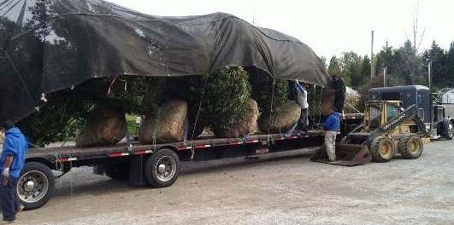

St. Joseph, Michigan, 2020-Jun-25 — /EPR Network/ — With the surge in COVID-19 victims surging throughout the Southeastern United States, Industrial Fabrics Manufacturer Tarps Now has seen a dramatic increase in open interest in its COVID-19 Protective Products and storm focused Disaster Recovery Tarp Products that help mitigate the effects of the COVID-19 pandemic, together with products and materials typically sought out in the wake of tropical storms and hurricanes.

[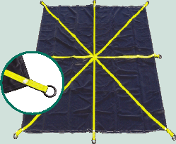](https://express-press-release.net/news/wp-content/uploads/2020/06/RoofingDebrisLiftingTarps_1.gif)Noting the 2020 Atlantic Hurricane Season officially began in June of this year Tarps Now confirms that it’s already been a busy summer helping its customers with materials used to help isolate airspace, as well as a wide range of advance stocking activities taken in anticipation of forecast tropical storms and major hurricanes. Noting newly emerging COVID-19 emerging “hot spots”, the urgency felt by many consumers has been stoked by weather experts predicting an above average hurricane season that’s expected to be 30% more active than normal, with as many as 16 named storms possibly making landfall in states like Florida, Texas, Georgia, South Carolina and North Carolina.

[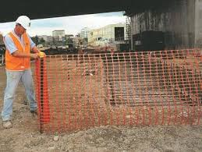](https://express-press-release.net/news/wp-content/uploads/2020/06/OrangeBarrierFencing_1.jpg)With these trends in place, many customers anticipate new state orders to “shelter at home”, with others especially concerned with the potential need to evacuate in the event of a major storm or hurricane. Especially so, if storm evacuation orders result in family members taking shelter with relatives or in public storm shelter forcing close proximity to persons representing a potential infection risk.

As a result of these conditions, consumers are aggressively stocking up on plastic sheeting materials that can be used to create air barriers which can be used to slow the virus laden air flows. Others are stockpiling supplies that help with rapid disaster recovery following major tropical storms and hurricanes.

**Disaster Recovery Products:**

<https://www.tarpsnow.com/waterproof-tarps.html>  
<https://www.tarpsnow.com/roof-debris-lifting-tarp.html>  
<https://www.tarpsnow.com/drain-tarps-leak-diverters.html>  
<https://www.tarpsnow.com/containment-tarps.html>  
<https://www.tarpsnow.com/orange-barrier-fence-safety-fence-snow-fence.html>  
<https://www.tarpsnow.com/shade-tarps.html>  
<https://www.tarpsnow.com/construction-tarps.html>  
<https://www.tarpsnow.com/mesh-shade-tarps.html>  
<https://www.tarpsnow.com/7-9-oz-hurricane-trampoline-mesh-tarps.html>  
<https://www.tarpsnow.com/nursery-landscape-tarps.html>  
<https://www.tarpsnow.com/heavy-duty-tarps.html>  
<https://www.tarpsnow.com/canvas-tarps.html>  
<https://www.tarpsnow.com/mesh-tarps.html>  
<https://www.tarpsnow.com/poly-tarps.html>  
<https://www.tarpsnow.com/vinyl-tarps.html>  
<https://www.tarpsnow.com/fire-resistant-tarps.html>  
<https://www.tarpsnow.com/specialty-tarps.html>  
<https://www.tarpsnow.com/tarp-products.html>  
<https://www.tarpsnow.com/13-oz-vinyl-building-enclosure-tarps-fr.html>

**About Tarps Now®**

Tarps Now® features an extensive online catalog of canvas tarps, poly tarps, custom tarps and covers, mesh tarps, vinyl tarps materials engineered to meet the needs of Hurricane recovery. As specialists in custom, canvas and vinyl tarps, they are the low-price leaders in their category, the company offers the convenience of fast, easy, online ordering, as well as a knowledgeable staff to guide customers through the specification process. Tarps Now® has the experience and scale to insure customer specifications are carefully followed and expectations exceeded.

Media contact:

Michael Dill, CEO  
Tarps Now, Inc.  
4133 M-139  
St Joseph, MI 49085  
888-800-1383  
sales@tarpsnow.com  
[www.tarpsnow.com](http://www.tarpsnow.com/)

Logo:

[](https://express-press-release.net/news/wp-content/uploads/2020/01/new-logo-tarps.jpg)

**Tarps Now® logo**