Summer Heat Sparks Heavy “Stay at Home” Consumer Demand for Screen Mesh Shade Tarps
St. Joseph, Michigan, USA, 2020-Jul-12 — /EPR Network/ — Due to heavy consumer demand spurned by Shelter in Place orders throughout the country, Tarps Now® is pleased to announce that it has expanded the scope of its offerings of Screen Mesh Shade Tarps that help reduce or eliminate exposure to intense sunlight and other forms of ultraviolet radiation experienced in a wide range of home applications.
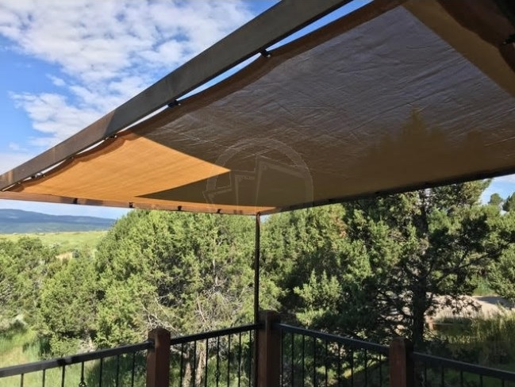
To meet the need for protective coverings around homes, animal habitats and other outdoor structures, Tarps Now® protective mesh tarp coverings are now offered in a wide range of mesh screen exposure ratings, weights, fabric grades and colors, each engineered to provide outstanding levels of protection from intense sunlight, as well as other forces of nature.
Applications for these new lines of Mesh Tarps extend to uses in and around homes, such as patios, decks, thresholds, gazebos, pools, picnic areas, barns, kennels and other outdoor recreational areas.
Conversely, many businesses are adopting the use of Mesh Shade Tarps to protect employees who work in areas where prolonged exposure to the elements exists such as in agricultural processing areas, animal feedlot areas, warehousing dock areas, shipping and receiving areas, and many other applications.
Further increasing risks of exposure from extended exposure to Ultra Violet radiation are Windscreens that offer varying levels of both UV protection and wind resistance, depending on the selected material and design.
Details are as follow:
Tarps Now® Shade Products:
https://www.tarpsnow.com/mesh-shade-tarps.html
https://www.tarpsnow.com/shade-tarps-polypro-mesh-95.html 95% Exposure
https://www.tarpsnow.com/86-knitted-shade-mesh-tarps.html 86% Exposure
https://www.tarpsnow.com/polypro-mesh-shade-tarps-70.html 70% Exposure
https://www.tarpsnow.com/polypro-mesh-shade-tarps-60.html 60% Exposure
https://www.tarpsnow.com/polypro-mesh-shade-tarps-50.html 50% Exposure
https://www.tarpsnow.com/polypro-mesh-shade-tarps-50.html 40% Exposure
https://www.tarpsnow.com/specialty-tarps.html
https://www.tarpsnow.com/tarp-products.html
About Tarps Now®
Tarps Now® features an extensive online catalog of canvas tarps, poly tarps, custom tarps, vinyl tarps and industrial divider curtains. As specialists in custom canvas and vinyl tarps, they are the low-price leaders in their category. The company offers the convenience of fast, easy, online ordering as well as a knowledgeable staff to guide customers through the specification process insuring their project will be completed on time and in budget. Tarps Now® has the experience and scale to insure customer specifications are carefully followed and expectations exceeded for every project, large or small.
Media contact:
Tarps Now, Inc.
4133 M-139
St Joseph, MI 49085
888-800-1383
sales@tarpsnow.com
https://www.tarpsnow.com
Logo:
Tarps Now® logo
Press release distributed via EPR Network (http://express-press-release.net/submit-press-release.php)

