SendBestGift.com delivering Rakhi and Friendship Day Gifts during Lock Down

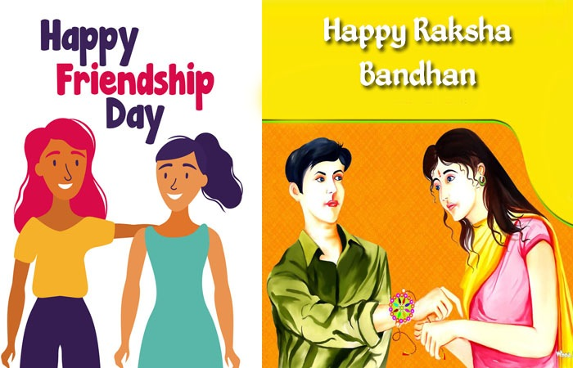
Gurgaon, India, 2020-Jul-15 — /EPR Network/ — Coronavirus pandemic has presented numerous challenges in front of the world since it’s outbreak at the fag end of the last year. As the world wrestles with these challenges, many green shoots have emerged as well. Having been locked up in our own homes, it seems like the fast paced life of the twenty-first century has come to a standstill. This much needed break has made everyone realize how disconnected they were with their beloved ones. These days loved ones are certainly on everyone’s mind. People cannot go out and hug their loved ones; however they sure can present their beloved ones with heartwarming gifts to reassert their love.
SENDBESTGIFT, one of the leading online gift shops, has taken upon itself to ensure that people can reach out to their near and dear ones from anywhere in the world. Keeping the upcoming festive season and COVID-19 lockdown in view, the website has updated its product portfolio and has upgraded its services to meet the gifting needs of millions of households in the nation.
Gifting has been used since ancient times to express the feelings of love, care and support. Today, people need love, care and support more than ever. And thus, the importance of gifting multiples mani-fold in these testing times. It now forms an important part of social lives. And why just social, it treads into the realms of personal life as well.
With just a few weeks left for Raksha Bandhan 2020 and friendship day, the company has started its Rakhi and Friendship day gifts delivery services despite the coronavirus advisory issued by the government. The website offers a wide array of unique gifts for friends. These friendship day gifts include friendship band, greeting cards, personalized gifts, cakes, chocolates, soft toys, combination gifts, and much more. For Rakhi gift ideas for brother & sister, the online gift portal offers designer Rakhi, chocolates, Rakhi with dry fruits, flowers, gift cards, sweets, cakes, Rakhi gift hampers, and so on.
“Online gifting is the future of gifting in India. This pandemic has shown us how important it is to go digital, do as much as we can from our homes. Understanding the need of the hour, SENDBESTGIFT has stepped up to the task of connecting hearts. We strive to deliver the best services to our customers and doing so has become more important in these difficult times. We have geared up for the massive demand during the upcoming festival season. From exclusive and extensive gift collections to a varied range of delivery services like the same day Rakhi gifts and same day friendship day gift delivery, we are ready with it all. Come shop with us, use our services to reach out to your dear ones and we promise to deliver excellence on your behalf. Stay home, stay safe and take care of yourself and your beloved ones,” says the founder and Chief Executive Officer of SendBestGift Narender Kumar.
The website has a very systematic approach to gifting and thus making it easier to place an order for gifts. It offers gifts for best friend boy as well as gifts for best friend girl. The website believes that there is a bond of friendship in every relationship and thus it offers friendship day gifts for girlfriend, boyfriend, wife, and husband too.
A delight for people looking to indulge in hassle free online gift shopping, the website offers separate sections for Rakhi gifts for brother and Rakhi return gifts for sister. Sisters can go to the Rakhi gifts for brother and choose gifts for their brothers and brothers can visit the Rakhi return gifts for sister section to place an order for the same.
SendBestGift has a range of gifts for various occasions and festivals. From numerous Rakhi variants like kundan Rakhi, kids Rakhi, rudraksha Rakhi, mauli Rakhi, beads Rakhi, zardosi Rakhi, fancy Rakhi and other to a plethora of Rakhi with gifts like Rakhi with dry fruits, Rakhi with sweets, Rakhi with chocolates, and Rakhi with personalized gifts, the website offers it all. In fact, this online gift shop offers pair Rakhi for brother and sister-in-law like the lumba Rakhi for bhaiya bhabhi.
Customers can send Rakhi with sweets, place an order for Rakhi with dry fruits, purchase Rakhi with cakes and soft toys or buy Rakhi with chocolates online from the comfort of their homes. The fast and precise provision of online Rakhi delivery ensures that the gifts are delivered to their respective destinations within the specified time.
Similarly, the website boasts of a diversified assortment of Friendship day gift ideas to help everyone commemorate the bond of camaraderie. One can use the platform of SENDBESTGIFT to titillate the taste buds of his/her friends with delicious friendship cake, amaze their best friend with a beautiful friendship flower delivery, present them with thoughtful personalized gifts, or satiate the cravings of his/her dear friend with an online friendship day chocolates delivery.
The website provides a customizable range of delivery options as well. Their delivery options include normal gift delivery, same day gift delivery, fixed time gift delivery and the midnight gift delivery in India. Customers can shop for gift for friendship day or other occasions and opt for any of these delivery options. In addition, customers can customize these delivery options to meet their personal gifting goals.
About Us
SENDBESTGIFT is a trusted online gift store serving its loyal customers since 2015. The company aims for 100% customer satisfaction and takes a customer centric approach for the same. Driven by a passion for innovation and a promise to achieve operational excellence, the company has come a long way from where it started. Today, the company is present in all parts of the nation and has many satisfied customers all over India. The website offers same day Rakhi delivery and same day gifts delivery in more than 1000 cities across India. In addition to it, the company offers midnight gift delivery in more than 100 cities. Operating round the clock, the company intends to make online gifting a household name.
Media contact:
support@sendbestgift.com
+91-9555151500
Press release distributed via EPR Network (http://express-press-release.net/submit-press-release.php)

