Billionaire Richard Branson Called a Trademark Bully by the Trademark Law Professors of University of Washington, School of Law

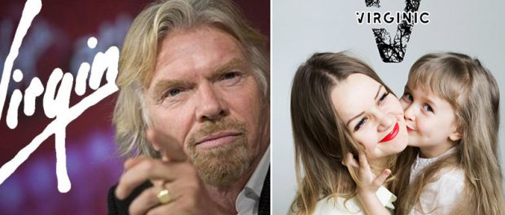
Westborough, MA, 2020-Jul-30 — /EPR Network/ — Virgin has targeted to attack over 300 small companies & non-profit charities. Common sense says that the word ‘virgin’ cannot be owned by one individual or organization but Virgin has deep pockets to destroy those who dare to fight for their rights.
“Opposing trademark registrations in unrelated fields is the classic behavior of a trademark bully,” says Mike Atkins, an attorney at Atkins Intellectual Property who teaches trademark law at the University of Washington, School of Law.
That’s why it came as a surprise that Branson decided to send a threatening cease-and-desist letter (where he tells the small start up to either commit a business suicide right away or else Virgin lawyers will destroy it within 30 days) to I Am Not A Virgin, a small eco-friendly denim label, claiming that the company’s name infringes on his copyright, as the Telegraph’s Laura Hubbert reported on the case.
Richard Branson’s lawyers demanded environmentally friendly start up jeans label ‘I Am Not A Virgin’ to cancel their trademark (a trademark they have been lawfully granted and owned for almost 4 years before they received the threat letter from Branson – reports Ms. HUBBERT in her article.
“I guess I could rename my jeans Not Made By Richard Branson” – comments sarcastically the founder of the brand. Branson also demanded the small business owner cease to sell current stock of the jeans and removes them from the stores which for a small business is a financial suicide and a loss of all start up investment costs essentially leading to the end of a business.
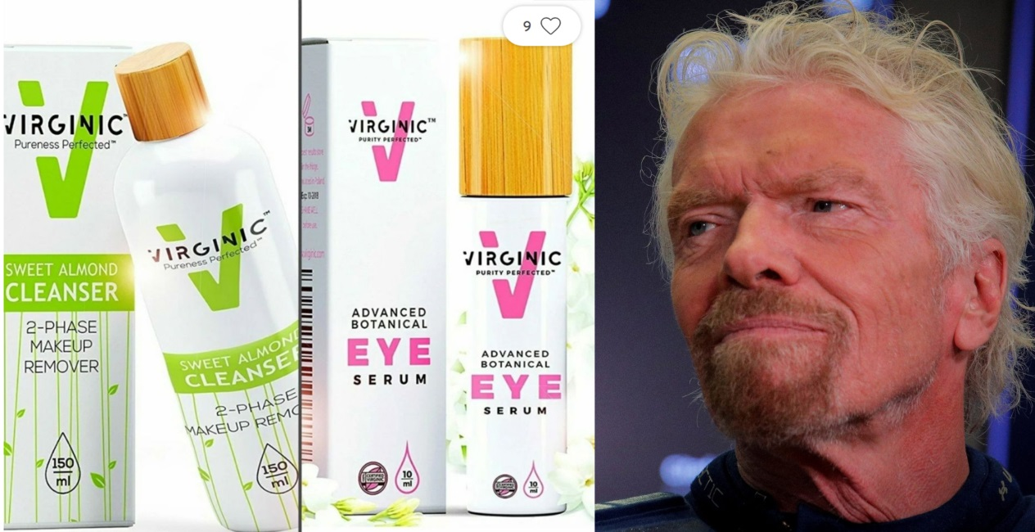
“Common sense says that the word ‘virgin’ cannot be owned by one individual or organization. In other words, it’s stupid to claim a colour of your own, let say a word. Branson, who’s also well known for his support of environmental causes, apparently has failed to see that” – says Anderson Antunes in his Forbes article about Virgin’s abuse on small entrepreneurs.
Attorney at law, Widerman Malek, summaries in his comments: “If Richard Branson has his way, it might be. ” He adds: “Although sometimes considered a bully in the trademark office, they remain unapologetic for their stance.”
According to multiple news reports, in the past several years, the Virgin group has targeted over 300 companies who used the word Virgin in their name, URL or marketing slogan. Unfortunately, many of these 300 companies are small businesses who do not have the resources to fight back against a multi-billion dollar company with hundreds or even thousands of lawyers on their retainer. These small businesses almost always settle simply because they cannot afford to fight.
Widerman Malek brings up some of the companies Virgin attacked:
- Virgin Vapors – a small vapor company located in California whose owner currently refuses to change its name despite being threatened by Virgin.
- The owners of domain names virginthreads.com, virginpublishing.com, virginstar.net, and virgincigar.com. The Virgin group alleges cyberpiracy for any company using the name virgin in their domain, even if it is not their business name.
- Author Cristina Crayn, who named one of her published books, “Tales from the Virgin Vault.”
- Virgin Valley Cab – a cab company in the Virgin Valley geographic location of Northwest Arizona, who recently came to an agreement with conglomerate to stop using the name.
- Las Virgenes United Educational Foundation – a nonprofit organization in the Las Virgenes School District. The Virgin Group attempted to block the trademark application. Evidently, any virgin will meet their criteria – no matter which language it’s in and if destroying charities for children is to take place.
- I Am Not A Virgin – a New York clothing company which specializes in creating and selling denim products.
- Virgin Air, a small airline in the American Virgin Islands, which no longer exists under this name due to Virgin’s lawsuits.
- CBS Studios, who may be opposed by the Virgin Group in an attempt to trademark the name Jane the Virgin, which they will use as a sitcom name.
- Last year, the Virgin group attempted to stop Valle Grande from trademarking a phrase that contained the words “virgin olive oil”, using the argument that Valle Grande currently only sells vinegar.
- In 2004, the conglomerate sued a tiny apparel retailer called Virgin Threads in federal court in New York; the retailer dropped the name a year later as they could not afford to battle with Virgin any longer.
- VIRGINIC – Purity Perfected – small cosmetics brand, selling “beyond organic”, handcrafted, allergy-free face creams in small batches. Virgin has been suing them with malicious, aggressive litigations, on the ongoing basis from 2018-2020 in multiple countries to starve them financially to business death, as Virgin did with other start ups. Interestingly, Virgin abandoned selling cosmetics years ago making public statements on their own website that they have no intention to sell beauty products. As of July 2020, VIRGINIC still refuses to be bullied and to give up their name.
The statement raised by all victims by Richard Branson and Virgin Group seem to be constant: they don’t feel it’s morally right to give up their start-up brands, hard work and dreams, just because there is a bully that says so.
“Why is Richard Branson trying to put us out of business?” – denim jeans company founder Peter Heron asked in this video posted to YouTube where he reads the harassment letter he has received from Richard Branson.
His video got over 13,000 supporters signing under it with their own name, encouraging Mr. Heron to not give up. Sadly, his brand was forced to surrender a year. Well done, Virgin lawyers, one more target destroyed.
Media contact:
Andrew Griffin
info@thebureauofinvestigativejournalists.com
Press release distributed via EPR Network (http://express-press-release.net/submit-press-release.php)

