Louis Lehot Talks About Successful Leadership & Beyond

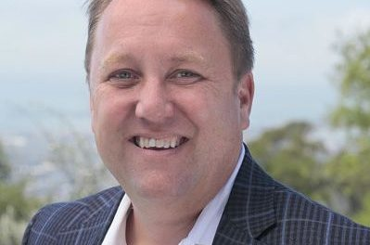
Palo Alto, California, USA, 2020-Aug-17 — /EPR Network/ — Louis Lehot, the founder of L2 Counsel, P.C., talks about his seven habits to being a better leader, especially when everyone is remote and distributed.
We sat down with Louis Lehot, the founder of L2 Counsel, P.C., and talked to him about his seven habits to being a better leader, especially when everyone is remote and distributed.
Louis Lehot is a corporate, securities, and M & A lawyer. His clients are public or private companies, financial sponsors, venture capitalists, investors, investment banks, in forming, financing, governing, buying, and selling companies.
According to Louis Lehot, here are some of the leadership qualities that good leaders strive towards:
Have Vision: Good leaders have a vision and purpose. They share their vision with their followers. A great leader explains why they are moving the team in one direction or another, shares their strategy and includes others in their action plan to achieve the desired goal.
Be understanding of evolving circumstances: Great leaders have empathy. Unfortunately, many leadership positions follow a dictatorial style failing to make a closer connection with their base. Understanding issues others in your circle have is the first step to become an effective leader.
Be ready to adapt to change: Covid-19 has thrown us for a loop, but as they say, when the going gets tough, the tough get going. Great leaders follow this rule. They are resilient, have a positive attitude, and rally their followers. Great leaders also focus on solutions, not problems.
Strong EQ: Good leaders understand people, connect with people emotionally, and understand the problems of others. Emotionally intelligent leaders have a higher degree of social awareness, more effective communication styles, and are good at resolving conflicts. Leaders who have EQ not only handle conflict in a better way, but also play an essential role in conflict resolution.
Inspire Others: Probably the most challenging job for a leader is to persuade others to see things as they do. They also know you inspire others by setting a good example. When the going gets tough, people look to see how leaders react to the situation. As a leader, thinking positive and a positive approach should be visible, inspiring others through your actions.
Louis Lehot Trusted Corporate and M&A Lawyer
Decision-Making Capabilities: Many leaders have a futuristic vision; great leaders can make the correct decision at the right time. Decisions in any situation will have a profound impact on others’ lives, which is why a leader should think long and earnestly before acting. Once the decision is made and executed, stand by it.
Accountability: When it comes to responsibility, make sure that you are accountable for what you are doing. Good leaders are self-aware, realize their mistakes, and work diligently to improve. Holding themselves responsible for their actions goes a long way in creating a sense of responsibility among your staff. It will serve as an example so that they go about the business more seriously.
Louis Lehot is the founder of L2 Counsel. Louis is a corporate, securities, and M & A lawyer. He helps his clients, whether they be public or private companies, financial sponsors, venture capitalists, investors, or investment banks, in forming, financing, governing, buying, and selling companies. He is formerly the co-managing partner of DLA Piper’s Silicon Valley office and co-chair of its leading venture capital and emerging growth company team.
L2 Counsel P.C. is an elite boutique law firm based in Silicon Valley designed to serve entrepreneurs, innovative companies, and investors with sound legal strategies and solutions.
Media contact:
Louis Lehot
L2 Counsel, P.C. 407, California Avenue, Suite #2 Palo Alto, California 94306
Direct voice: +1.650.796.7280
Email: louis.lehot@l2counsel.com
===
Press release distributed via EPR Network (http://express-press-release.net/submit-press-release.php)

