CoapTech Raises $7 Million in Series B Funding Led by Hunniwell Lake Ventures
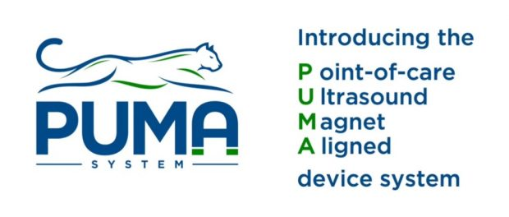Baltimore, MD, 2020-Aug-28 — /EPR Network/ — CoapTech LLC (Baltimore, MD), a leading medical device start-up pioneering the world’s first and only ultrasound-based feeding tube placement system, announced today the closing of a Series B investment of $7 million led by Palo Alto-based medical device venture capital firm Hunniwell Lake Ventures. The financing will be used to fund CoapTech’s commercialization of its FDA-cleared PUMA-G System.
By simplifying gastrostomy procedures to the point where they can be conducted at the patient’s bedside with ultrasound, hospitals using PUMA-G benefit by freeing up surgical suites and personnel resources for COVID and other clinical priorities, minimizing cross-contamination, and improving efficiencies in care.
CoapTech was founded by critical care physician Dr. Steven Tropello and clinical innovation researcher Howard Carolan, to reduce unnecessary delays, harm, and costs for feeding tube placement, a vital therapy for millions of patients each year around the world.
Howard Carolan, CEO and Co-Founder, states: “We have been receiving fantastic feedback from hospitals in our initial launch program, which are using the PUMA-G System to revolutionize feeding tube placement. By using ultrasound at the patient bedside, rather than the conventional approach of orchestrating expensive and inefficient consults, critical care physicians are completing these procedures in minutes, on the same shift a feeding tube is first indicated. We’re seeing early indications those efficiencies result in patients leaving the ICU sooner, which saves hospitals many thousands of dollars per admission. A substantial portion of this new funding is from physicians who have seen the device and believe it can become the new default method for feeding tube placement.”
Dr. Steven Tropello elaborates, “the PUMA-G System is proving itself ready for standard-of-care adoption for safe and timely gastrostomy tube placement. It is also proving a powerful approach in the fight against COVID, by completely eliminating transport of patients, team members, and reprocessed tools throughout the hospital in favor of a sterile, disposable, bedside solution. I am also very excited about other clinical applications of the PUMA platform we are developing and aim to have for patients in the near future.”
This Series B investment was led by Hunniwell Lake Ventures, a Palo Alto-based medical device venture capital firm.
Daniel Teo, Managing Partner at Hunniwell Lake Ventures, further states “Coaptech’s PUMA System has the potential to transform gastrostomy and many other surgical procedures by allowing them to be performed using ultrasound at the bedside, in hospitals, ambulatory centers, skilled nursing facilities, and LTACHs (Long-term Acute Care Hospitals). This also benefits patients by bringing the procedure closer to the Point-of-Demand (PoD) and giving them more options with a larger community of medical providers capable of performing the procedure.
About CoapTech
Founded in Baltimore, Maryland, CoapTech seeks to bring to the international market breakthrough medical devices utilizing the Point of care Ultrasound Magnet Aligned (PUMA) System, a patented technology developed by Dr. Steven Tropello most notably leveraged in the PUMA-G system. PUMA-G was conceived by Dr. Tropello after the critical care physician became frustrated by the inefficiency of the current feeding tube placement system in hospitals. The novel PUMA technology has the potential to disrupt multiple medical procedures with new, minimally invasive alternatives based on ultrasound – substantially reducing costs and improving patient experience, safety, efficiencies, and access.
About Hunniwell Lake Ventures
Founded by Richard Fang and Daniel Teo, successful medical device entrepreneurs turned venture capitalists, Hunniwell Lake Ventures’ mission is to make surgery safer, more accessible and less invasive by investing in surgical innovations that help medical providers See, Treat and Heal better.
Media contacts:
CoapTech
info@coaptech.com
www.coaptech.com
Hunniwell
info@hunniwell.com
www.hunniwell.com
===
Press release distributed via EPR Network (http://express-press-release.net/submit-press-release.php)

