Mesh Tarps in High Demand as Work at Home Movement Encourages Renovation at Home and Businesses

Tarps Now® logo
St. Joseph, Michigan, USA, 2020-Sep-08 — /EPR Network/ — Tarps Now® has announced the addition of new lines of industrial grade Mesh Tarps that offer a wide range of uses as protective coverings around home patios, decks, thresholds, gazebos, pools, picnic areas, barns, kennels and other outdoor recreational areas.
The new lines of Mesh Tarps offered by Tarps Now® are being placed in service as Windscreens in agriculture facilities, outdoor livestock agricultural processing areas, animal feedlot areas, shipping and receiving areas, buildings, warehouses and other outdoor structures benefiting from reducing the harmful effects of extended exposure to the elements.
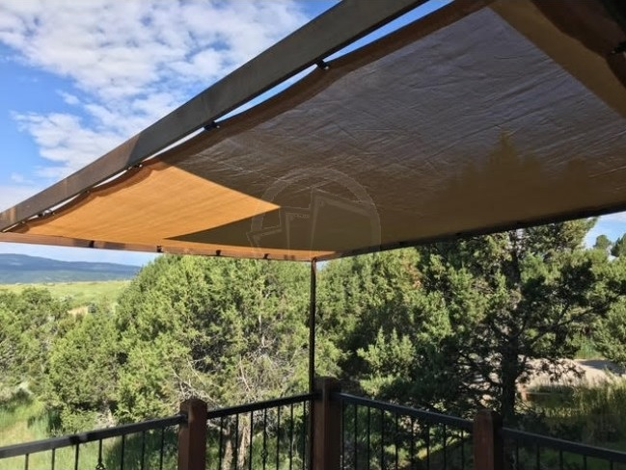
To meet demand, Tarps Now® custom manufactures protective mesh tarp coverings in a variety of mesh screen exposure ratings, weights, fabric grades and colors that are all engineered to provide outstanding levels of protection from high winds and intense sunlight, where extended exposure to Ultra Violet radiation is recognized to contribute to skin cancer and other ill health effects.
Tarps Now® also offers a complete line of industrial grade mesh fabrics that provide very specific levels of exposure, as well as the ability to choose from standardized sizes, as well as a high degree of customization to meet very specific applications. These include industrial strength debris netting, fire retardant mesh tarps, hurricane grade mesh tarps and other types of specialty applications.
Details on exposure rated Mesh Tarps and supporting fabrics are as follows:
Tarps Now® Mesh Tarpsper Exposure Rating:
https://www.tarpsnow.com/shade-tarps-polypro-mesh-95.html 95% Exposure
https://www.tarpsnow.com/86-knitted-shade-mesh-tarps.html 86% Exposure
https://www.tarpsnow.com/polypro-mesh-shade-tarps-70.html 70% Exposure
https://www.tarpsnow.com/polypro-mesh-shade-tarps-60.html 60% Exposure
https://www.tarpsnow.com/polypro-mesh-shade-tarps-50.html 50% Exposure
https://www.tarpsnow.com/polypro-mesh-shade-tarps-50.html 40% Exposure
https://www.tarpsnow.com/7-9-oz-hurricane-trampoline-mesh-tarps.html
https://www.tarpsnow.com/privacy-fence-screen-mesh-netting.html
https://www.tarpsnow.com/mesh-fabric-by-the-yard-roll.html
https://www.tarpsnow.com/debris-scaffold-debris-netting.html
https://www.tarpsnow.com/heavy-duty-vinyl-mesh-tarps.html
https://www.tarpsnow.com/geotextile-mesh-screens.html
https://www.tarpsnow.com/fire-resistant-mesh-tarps.html
https://www.tarpsnow.com/mesh-shade-tarps.html
https://www.tarpsnow.com/specialty-tarps.html
https://www.tarpsnow.com/tarp-products.html
About Tarps Now®
Tarps Now® features an extensive online catalog of canvas tarps, poly tarps, custom tarps, vinyl tarps and industrial divider curtains. As specialists in custom canvas and vinyl tarps, they are the low-price leaders in their category. The company offers the convenience of fast, easy, online ordering as well as a knowledgeable staff to guide customers through the specification process insuring their project will be completed on time and in budget. Tarps Now® has the experience and scale to insure customer specifications are carefully followed and expectations exceeded for every project, large or small.
Media contact:
Tarps Now, Inc.
4133 M-139
St Joseph, MI 49085
888-800-1383
sales@tarpsnow.com
https://www.tarpsnow.com
Press release distributed via EPR Network (http://express-press-release.net/submit-press-release.php)

