Kickstarter Project ‘Did Ya Wheatgrass’ Implements Food-Safety Lab Testing to Validate Quality and Integrity

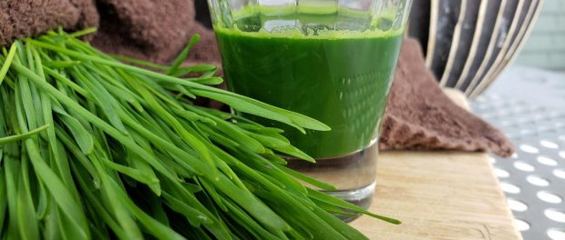
Pearland, TX, USA, 2020-Sep-15 — /EPR Network/ — Did Ya Wheatgrass launches their Kickstarter project, on Sept. 22, 2020. Besides growing, harvesting and juicing their own wheatgrass, Did Ya Wheatgrass validates their juice quality and integrity by food-safety testing their wheatgrass juice at an approved Food Technology & Processing laboratory. This ensures the highest quality product to the consumer.
The Texas Department of State Health Services (DSHS) states, “It is critical that the wheatgrass is grown from seeds that are processed and obtained from an approved source. The seeds need to be stored and handled to prevent the contamination with any pathogens.” The DSHS continues, “According to FDA, wheatgrass juice is a low acid juice and, under the proper conditions, the raw product is susceptible to the growth of Clostridium botulinum.”
Did Ya Wheatgrass founder Raquel Payan adds, “People don’t get to see the growing process that goes on behind the scenes. And the only way to validate the quality and integrity of the juice is by food-safety testing the wheatgrass juice at an approved Food Technology & Processing laboratory. We want to provide the consumer with the highest quality wheatgrass juice product.” People will ask Payan, ‘How do you get your wheatgrass so sweet tasting? How is it so green?’ Payan responds by saying that the secret is in the growing process. Did Ya Wheatgrass pays considerable attention to the growing process, since it is critical to the quality of juice produced. As a result, Did Ya Wheatgrass Juice Pops are E. Coli free, Salmonella free and Clostridium botulinum free.
The Kickstarter Project, ‘Did Ya Wheatgrass Juice Pops Food-Safety Lab Tested (Vegan Food)’, is scheduled to launch on Sept. 22, 2020. Take a peek and sign up for notifications to stay tuned. For additional information, visit their website: https://www.didyawheatgrass.com.
Media contacts:
Raquel Payan
Did Ya Wheatgrass
2526 Business Center Dr
77584/281-850-1119
dywhtgs@didyawheatgrass.com
https://www.didyawheatgrass.com
Logo:
Did Ya Wheatgrass logo

Press release distributed via EPR Network (http://express-press-release.net/submit-press-release.php)

