2020 Hurricane Season Squeezing Supplies of Tarps and Industrial Grade Coverings

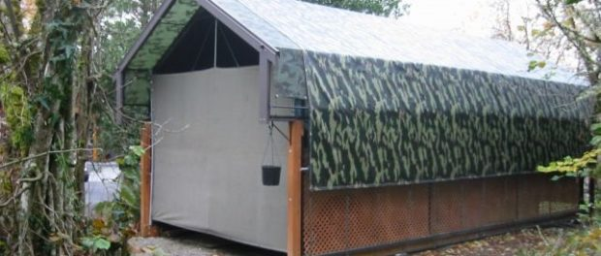
St. Joseph, Michigan, USA, 2020-Sep-21 — /EPR Network/ — With an average hurricane season typically producing twelve storms over the six month Atlantic storm season, over twenty named storm systems have been recorded by the National Hurricane Center over the last three months. In addition, five active Atlantic tropical storm systems tied the record for simultaneous tropical storms in the Atlantic basin by mid-September, while tropical storm Beta advances through the Gulf toward the Texas and Louisiana coastlines.
These unprecedented weather conditions have lead to significant demand in tarps and coverings utilized to create temporary shelters, repair roofing, cover windows, divert flood waters, lift storm debris, protect exposed equipment, inventories and vehicles has U.S. based Tarps Now® operating at full capacity to meet demand by government agencies, non-profit organizations, businesses and consumers.
In many cases, stock and custom sized tarps, covers and industrial fabrics are being ordered for emergency stockpiling to meet sudden storm related disaster recovery needs. In these cases, Tarps Now® is meeting demand with stock sized roofing tarps, as well as Debris Lifting Tarps and Hurricane Mesh Tarps engineered to meet emergency situations. In addition, custom tarp manufacturing is offered to provide a full range of options to meet specialized disaster recovery applications. Stock and custom options are detailed as follows:
Tarps Now® Disaster Recovery Products:
https://www.tarpsnow.com/custom-tarps-made.html
https://www.tarpsnow.com/heavy-duty-tarps.html
https://www.tarpsnow.com/roofing-tarps.html
https://www.tarpsnow.com/canvas-tarps.html
https://www.tarpsnow.com/mesh-tarps.html
https://www.tarpsnow.com/poly-tarps.html
https://www.tarpsnow.com/vinyl-tarps.html
https://www.tarpsnow.com/fire-resistant-tarps.html
https://www.tarpsnow.com/specialty-tarps.html
https://www.tarpsnow.com/tarp-products.html
https://www.tarpsnow.com/debris-scaffold-debris-netting.html
About Tarps Now®
Tarps Now® features an extensive online catalog of canvas tarps, poly tarps, custom tarps and covers, mesh tarps, vinyl tarps and industrial divider curtains. As specialists in custom, canvas and vinyl tarps, they are the low-price leaders in their category. The company offers the convenience of fast, easy, online ordering as well as a knowledgeable staff to guide customers through the specification process insuring their project will be completed on time and in budget. Tarps Now® has the experience and scale to insure customer specifications are carefully followed and expectations exceeded for every project, large or small.
Media contacts:
Tarps Now, Inc.
4133 M-139
St Joseph, MI 49085
888-800-1383
sales@tarpsnow.com
www.tarpsnow.com
Logo:
Tarps Now® logo

Press release distributed via EPR Network (http://express-press-release.net/submit-press-release.php)

