Travel Packages to Kenya Masai Mara 3 Days Great Budget Discounted Offers

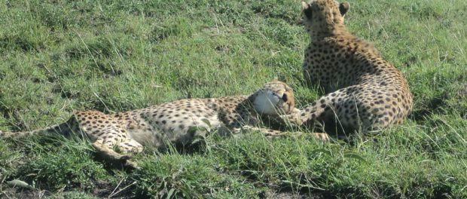

NAIROBI, Kenya, 2020-Sep-22 — /EPR Network/ — Traveling off peak can be a thrilling experience when there are less people crumbling for the same experience.
Cruzeiro Safaris Kenya has offered all travelers travel Discount on the popular safari to 3 days Masai Mara experience. which is now at USD350 per adult
The full details are found here: https://cruzeiro-safaris.com/nairobi-tours/product/3-day-masai-mara-safari-budget-travel/
Popular Tour to the Nairobi National Park and Giraffe center is also available always for a minimum of 2 people
https://cruzeiro-safaris.com/nairobi-tours/product/nairobi-national-park-tour-and-giraffe-center/
Travel Period Validity: 01 September to 23 December, 2020
The experience is to be experienced there are no similar days in the vast plains of Masai Mara.
To contact them for the offer send an email on info@cruzeiro-safaris.com
For other Travel Services:
Website : https://www.cruzeiro-safaris.com
Nairobi Tours Site: https://cruzeiro-safaris.com/nairobi-tours
About Cruzeiro Safaris Kenya
Cruzeiro-safaris.com is established in Kenya, incorporated in 2004. Its core business is safari packages and day tours complemented by air travel. It has a well-established wealth of experience in arranging memorable tours and safaris and has established a client base who provide with repeat business year after year. Join us on facebook, twitter and youtube. Safaris in Kenya may be tailored to the tourist taste and can extend to Tanzania and Uganda. Browse and read reviews on trip advisor page and one can also book from trip advisor link.
For further information and reservations, contact;
Claudia Kabui
Mobile : +254-(0) 722-370833 (Kenya)
Sales: + 254 (0) 710-729021 (Kenya)
Email: info@cruzeiro-safaris.com
Website: | https://www.cruzeiro-safaris.com and https://cruzeiro-safaris.com/nairobi-tours/

Press release distributed via EPR Network (http://express-press-release.net/submit-press-release.php)

