Rapid Sales Growth for Tarp Coverings among Construction Contractors Signals Potential for Economic Recovery
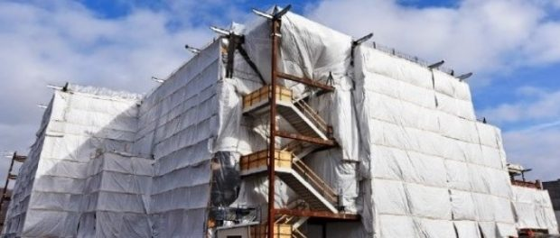
St. Joseph, Michigan, 2020-Oct-01 — /EPR Network/ — Tarps Now® today announced increases in production of Industrial Grade Tarps and Covers engineered to meet heavy order flow demands initiated by Engineering, Procurement and Construction (“EPC”) contractors throughout the North America. Nationally known EPC contractors increasingly turn to Tarps Now® for a wide range of Heavy Duty Tarps and Covers engineered to help EPC contractors meet a wide range of construction milestones associated with engineering, developing, constructing and facilitating the opening of a wide range of facilities serving heavy industry.
Examples of industries served includes solar and wind power projects, utility plant construction, oil and gas pipelines, highway and road construction, retail shopping centers, multi-family community projects, and healthcare industry facility projects.
The company also provides support services to assist EPC contractors in selecting correct tarps products and coverings to meet specific application needs, as well as on-site delivery estimates which are frequently needed to meet tight construction milestone schedules. Support services including provisioning of stock sized tarps and coverings, as well as use of large scale custom tarp coverings needed to protect work in progress, concrete curing, heavy equipment and construction zones.
Growth has been accelerated due to the availability of custom tarp ordering technology available on the Company’s website that contributes to expedited order processing, fabrication, shipment and deliveries. Construction managers cite the accuracy of cost quotes, rapid order processing and timely on-site deliveries of critical to meet milestone events during the construction process. Major product lines serving the EPC Construction industry are as follows:
Tarps Now® Construction Industry Tarp Covering Products Include:
https://www.tarpsnow.com/construction-tarps.html
https://www.tarpsnow.com/concrete-curing-blankets.html
https://www.tarpsnow.com/debris-scaffold-debris-netting.html
https://www.tarpsnow.com/containment-sandblasting-mesh-barrier-fr.html
https://www.tarpsnow.com/debris-lifting-tarp-snow-tarps.html
https://www.tarpsnow.com/drain-tarps-leak-diverters.html
https://www.tarpsnow.com/geotextile-mesh-screens.html
https://www.tarpsnow.com/airbag-tarps.html
https://www.tarpsnow.com/salvage-covers-and-tarps.html
https://www.tarpsnow.com/painters-drop-cloths.html
https://www.tarpsnow.com/heavy-duty-tarps.html
https://www.tarpsnow.com/heavy-duty-vinyl-tarps.html
https://www.tarpsnow.com/waterproof-canvas-tarps-breathable-tarps.html
https://www.tarpsnow.com/heavy-duty-poly-tarps.html
https://www.tarpsnow.com/heavy-duty-vinyl-mesh-tarps.html
https://www.tarpsnow.com/hypalon-tarps-csm-tarps.html
https://www.tarpsnow.com/neoprene-coated-nylon-tarps.html
https://www.tarpsnow.com/industrial-tarps.html
https://www.tarpsnow.com/industrial-covers.html
https://www.tarpsnow.com/canvas-tarps.html
https://www.tarpsnow.com/custom-fence-screen.html
About Tarps Now®
Tarps Now® features an extensive online catalog of heavy duty tarps, canvas tarps, poly tarps, custom tarps, vinyl tarps and industrial divider curtains. As specialists in custom canvas and vinyl tarps, they are the low-price leaders in their category. The company offers the convenience of fast, easy, online ordering as well as a knowledgeable staff to guide customers through the specification process insuring their project will be completed on time and in budget. Tarps Now® has the experience and scale to insure customer specifications are carefully followed and expectations exceeded for every project, large or small.
Media contact:
Michael Dill, CEO
Tarps Now, Inc.
4133 M-139
St Joseph, MI 49085
888-800-1383
sales@tarpsnow.com
https://www.tarpsnow.com
Logo:
Tarps Now® logo
===
Press release distributed via EPR Network (http://express-press-release.net/submit-press-release.php)

