**Accents Inserts Releases V2 – New Stronger Longer-lasting Insoles**

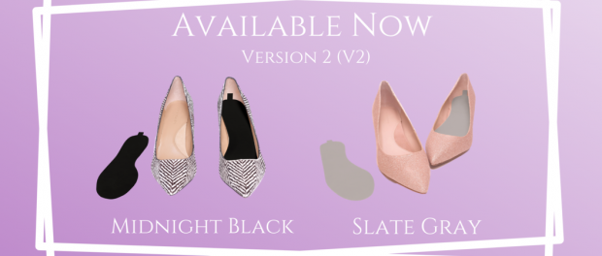

**Accents Inserts Releases V2 - New Stronger Longer-lasting Insoles**

Emeryville, CA, U.S.A, 2020-Oct-02 — /EPR Network/ — Accents Inserts today announced the release of its new upgraded Version Two (V2) insoles. V2 improves upon the already existing line. This new and enhanced product brings you the same great core benefits from the first version; sweat-absorption, odor-elimination, patented adhesive technology and custom-shaped design. The newest addition is an added benefit of a stronger, more durable fabric that is still as ultra-thin as the original. The advantage of V2 updated fabric is that it can be worn for multiple days of activity.

“Evolving is the Goal,” **Rachele Cazarez**, CEO/Founder of Accents Inserts stated. “We always want to improve upon our products. I am continuously conducting research because I am striving to keep making Accents better. Since the product can now last longer it can increase the lifespan of shoes. We simplified our packaging, to make it more environmentally-friendly. We also make sure to source and manufacture all components of the supply chain within the United States; by doing so we lower our global footprint. We will continue to become a better company; improve as we focus on evolving.”

Accents V2 has increased its durability to impact the longevity of the product. This is great for active individuals. Now they do not need to worry about sweat buildup and slippage, foot odor buildup or dirty shoes. Plus, they do not have to slow down by having to cut them to size. They just insert them, then Accents can gather all the sizable unpleasantness that accumulates in their shoes while they are going about enjoying each day without having to worry about it.

**Features and Benefits of Accents Inserts V2 include:**

* Sturdier fabric, this allows the inserts to last longer. Much research was put into testing to acquire the best quality fabric possible.
* Colors for this new line are Midnight Black and Slate Gray.
* Sustainability, to help with lowering its global footprint, Accents Inserts is sourcing and obtaining all of its materials in the USA . It is also utilizing manufacturers from the USA.

People will encounter the unpleasant part of an active life when they wear their shoes. Whether they have worn socks or not does not matter, they all have sweat, dirt and foot odor buildup in them. What they do not know is that they can now avoid this problem if they use a barrier between their feet/socks and the soles of their shoes. This is where Accents Inserts are found to be the answer to these problems by being that necessary barrier. These inserts gather up the sweat and offensive smell along with the dirt, which are then just lifted out and thrown away. Then next time they wear their shoes, inserting a new pair allows them a fresh start.

Accents Inserts V2 are available in colors Midnight Black and Slate Gray. The additional benefit is that the upgraded quality fabric enhances the life of shoes for everyone by helping prolong their use.

To learn more about Accents Inserts, click here: [https://www.accentsinserts.com](https://www.accentsinserts.com/)  
They are available on Amazon at: <https://www.amazon.com/Accents-Shoe-Inserts-Sweaty-Feet/dp/B08G5C2FDQ?ref_=ast_sto_dp&th=1>

**About Accents Inserts:**  
Accents Inserts is a Latina-Owned and operated company that is focused on creating great quality shoe liners. Their patented technology offers a unique solution that stands out from others on the market. The company motto is: “Everyone deserves to strut through life in comfort.”

**Media contact:**

Marketing Department  
Accents Inserts

Logo:

[](https://express-press-release.net/news/wp-content/uploads/2020/04/Accents-Inserts-Logo-4.png)

Accents Inserts Logo

===

Press release distributed via EPR Network (<http://express-press-release.net/submit-press-release.php>)