U.S. Presidential Election Wagering Heats Up

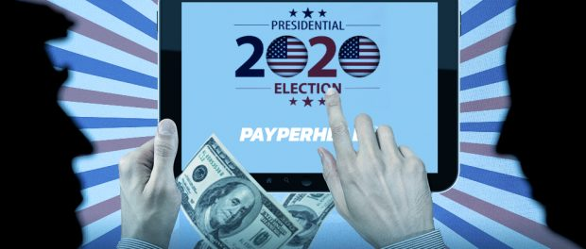U.S. Presidential Election Wagering Heats Up
San Jose, Costa Rica, 2020-Oct-08 — /EPR Network/ — The 2020 U.S. Presidential Election on Nov. 3 has already proven one of the most contentious in American politics’ history. From now until the first Tuesday in November, neither candidate, incumbent Donald Trump nor challenger Joe Biden, figures to become less combative. And local bookies have already taken a significant amount of bets from players; meaning this could be the most profitable election for independent bookmakers in US history according to Payperhead.com.
The Democrats’ dislike of Trump and Republicans’ fear for a Biden Presidency has already led to one of the most wagered upon Presidential Elections ever. On Sep. 1, a leading sportsbook accepted a massive over $67,000 wager on Donald Trump.
Although Biden remains the favorite, wagers like that have driven Trump’s odds down on sportsbook software platforms like PayPerHead. Since the large wager, Trump and Biden have had their first debate, Vice Presidential candidate Kamala Harris and Mike Pence have also debated, and President Trump has tested positive for the coronavirus.
A Supreme Court Justice Senate Confirmation Hearing and two more Presidential Debates could determine where wagering action lands before Election Day. The second debate between Trump and Biden is on Oct. 15, while the third organized verbal showdown takes place on Oct. 22.
In 2016, PayPerHead saw an uptick in U.S. Presidential Election betting about two weeks before American citizens headed to the polls. The wagering trends appear to be on a similar path with the bulk of election bets most likely happening in the fifteen or so days before the election, just like what happened four years ago.
In the last Presidential Election, Hillary Clinton held a percentage lead in the national polls with about two weeks to go. Clinton remained the favorite, but Trump gained more wagers the closer the U.S. got to choosing their next president. Overall wagering, bets on Clinton and Trump, also significantly increased in the final stretch before the election.
PayPerHead Product Manager Nate Johnson expects action in the final fifteen days before Nov. 3 to resemble what happened in 2016 with one caveat, PayPerHead doesn’t know where the action will land. Johnson said, “We saw action on Trump. This year could be different with players backing Biden. Not that our agents care…but they love all the action.”
“Bookie agents on the PayPerHead platform don’t care so much about where the action goes because they’ve got tools to manage action no matter which candidate their players prefer,” Johnson said. He added, “We expect a flood of wagers on our platform after the second debate. If Trump performs well, everyone will know he’s over the coronavirus. Hopefully, they both perform well, and our agents see action on both candidates.”
About PayPerHead:
Founded in 1997, PayPerHead.com is the leading choice for serious bookies. The company’s Agent Payment Solution (APS) is the only in the pph sportsbook industry that allows for online collections and payments. Bookies can offer their players two live dealer casinos, a variety of digital casino games, two live in-game betting platforms, a poker room, wagering options on every available sports league, and horse racing. PayPerHead also has the best in industry referral program so agents can add to their profitability and it prides itself on providing industry-leading, top-class customer service with over 20 plus years of experience.
For more information, visit https://payperhead.com or contact:
sales@247servicenow.com
1-800-605-4767
Logo:

PayPerHead logo
Press release distributed via EPR Network (http://express-press-release.net/submit-press-release.php)

