It’s Time To Promote Civility In the United States

JUNEAU, Alaska, 2020-Oct-13 — /EPR Network/ — What started out as a way to get his daily 10,000 steps, a local man hopes in the long run will change the course of dialog in America.
For 12 years during the cruise season, Robert Steinke has been coming to the Port in Juneau to greet cruise customers and welcome them aboard humpback whale watching excursions. With the pandemic in full swing, he still feels drawn to the Port and would visit frequently – focusing on his daily 10,000 step goal rather than greeting customers. These walks allowed for releasing some built up pandemic energy and passing the time listening to a little talk radio or podcasts.
It was during one of these daily walks while listening to various podcast’s that Robert was struck with an idea. “Sometimes on these call-in shows, things can get a bit heated,” stated Steinke, “then, one of the callers said ‘Why can’t we just bring back civility?’ I couldn’t get that thought out of my mind, I went to bed that night thinking about the idea of civility and how important that concept is to a democracy.” From that day at the Port, Steinke was inspired to help spread the idea of bringing back civility.
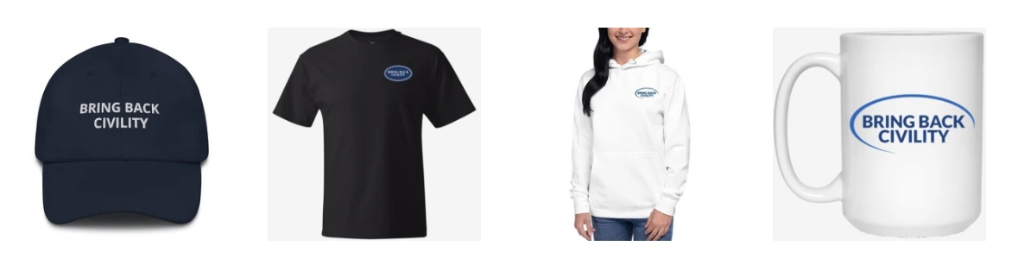
After chatting with his wife and doing some research, Steinke decided the best way to change the tone was for individuals to publicly share the concept of civility – almost brand themselves with the idea of ‘be civil’. So, Steinke launched the website BringBackCivility.com where individuals can brand themselves with the ideal of being civil to each other.
“We don’t have to agree on everything, or even anything, to be civil to each other. Being civil is really a choice,” stated Steinke. “This is just a simple way to remind ourselves and others to be kind and be civil to each other.” Since the launch of the website, the most popular items have been face masks and hats. Both come in a variety of colors and designs to suit everyone. “I like the face masks, they make a few different statements when you wear one,” stated Steinke.
The site will be up at least until the end of the year. Most gear will be shipped in 3-7 days and can be shipped worldwide. The company is also taking bulk orders from shops that are interested in carrying the line.
###
About BringBackCivility.com:
Founded in Juneau, AK by tourism veteran Robert Steinke, BringBackCivility.com hopes to change the tone of the discussion and remind individuals that there is more that unites us than divides us. Learn more at www.BringBackCivility.com
Media contact:
Robert Steinke
Robert@BringBackCivility.com
(907) 957-6712
Logo:
BringBackCivility.com logo

Press release distributed via EPR Network (http://express-press-release.net/submit-press-release.php)

