**Tarps Now® Announces Expansion of Industrial Mesh Fabrics Division**

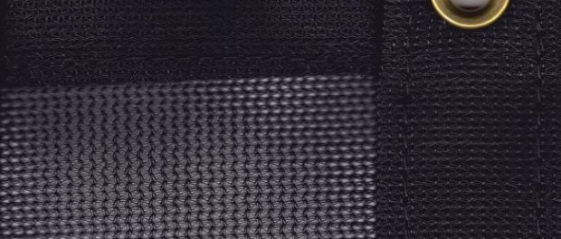

St. Joseph, Michigan, 2020-Nov-10 — /EPR Network/ — Industrial Fabrics Producer Tarps Now® today announced the expansion of its Industrial Mesh Division due to increasing demand of its Industrial Grade Mesh Fabrics as well as mesh tarps frequently used across multiple residential and commercial contractors, as well as the agricultural and farm segments, and a wide range of industry groups utilizing the mesh fabrics for varying applications.

Segments enjoying the most rapid growth includes applications as protective coverings around homes, animal habitats and other outdoor structures. To meet these demands, the Company routinely custom manufactures protective mesh fabrics in a variety of mesh screen exposure ratings, weights, fabric grades and colors in order to reduce extended exposure to direct sunlight and its associated ultraviolet radiation, as well as exposure to high winds wind resistance, depending on the selected material and design.

Examples of uses for Industrial mesh fabrics extend to uses in and around homes, such as patios, decks, thresholds, gazebos, swimming pools and picnic areas. In the context of sports, Industrial mesh is frequently used as a wind break for outdoor tennis courts, golf course driving ranges and batting cages. In agricultural settings, facilities used for house livestock, such as barns, kennels and other outdoor stock areas frequently use industrial mesh. Conversely, businesses adopt the use of mesh fabrics to protect employees who work in areas where prolonged exposure to the elements exists. Examples include agricultural processing areas, animal feedlot areas, warehousing dock areas, shipping and receiving areas, and many other industrial manufacturing applications. Details are as follow:

**Tarps Now® Shade Products:**

<https://www.tarpsnow.com/mesh-shade-tarps.html>  
<https://www.tarpsnow.com/shade-tarps-polypro-mesh-95.html> 95% Exposure  
<https://www.tarpsnow.com/86-knitted-shade-mesh-tarps.html> 86% Exposure  
<https://www.tarpsnow.com/polypro-mesh-shade-tarps-70.html> 70% Exposure  
<https://www.tarpsnow.com/polypro-mesh-shade-tarps-60.html> 60% Exposure  
<https://www.tarpsnow.com/polypro-mesh-shade-tarps-50.html> 50% Exposure  
<https://www.tarpsnow.com/polypro-mesh-shade-tarps-50.html> 40% Exposure  
<https://www.tarpsnow.com/specialty-tarps.html>  
<https://www.tarpsnow.com/tarp-products.html>

**About Tarps Now®**

Tarps Now® features an extensive online catalog of canvas tarps, poly tarps, custom tarps, vinyl tarps and industrial divider curtains. As specialists in custom canvas and vinyl tarps, they are the low-price leaders in their category. The company offers the convenience of fast, easy, online ordering as well as a knowledgeable staff to guide customers through the specification process insuring their project will be completed on time and in budget. Tarps Now® has the experience and scale to insure customer specifications are carefully followed and expectations exceeded for every project, large or small.

**Media contact:**

Michael Dill, CEO  
Tarps Now, Inc.  
4133 M-139  
St Joseph, MI 49085  
888-800-1383  
sales@tarpsnow.com  
[https://www.tarpsnow.com](https://www.tarpsnow.com/)

Logo:

[](https://express-press-release.net/news/wp-content/uploads/2020/01/new-logo-tarps.jpg)

**Tarps Now® logo**

===

Press release distributed via EPR Network (<http://express-press-release.net/submit-press-release.php>)