Stuck for That Perfect Adult Stocking Stuffer? Need a Mommy’s Time Out After A Long Day At Home?

East Hanover, NJ, 2020-Dec-07 — /EPR Network/ — Mommy’s Time Out Wine is the perfect stocking stuffer, and can be enjoyed by just about anyone on your adult stocking stuffer list. Mommy’s Time Out features four varieties including Mommy’s Time Out Pinot Grigio, Mommy’s Time Out Moscato, Mommy’s Time Out Delicious Red, and Mommy’s Time Out Delicious Pink. All are made from grapes grown in Italy and have wonderful fruity undertones. All the wines are fresh, fruity and well balanced, and are delicious for sipping with snacks or to complement a meal.
Being at Home during the Holidays has changed. Hasn’t it? It used to be the place where we all relaxed after a hard day at work. Not now. We may be home monitoring the virtual learning of our children. We might be working longer hours, because work is now remote, and we still have to monitor the virtual learning of our children. We might have to make them lunch because our kitchen is now the school cafeteria. The producers of Mommy’s Time Out Wine understand and have offered the following thoughts to make the holidays the most enjoyable time of the year.
Keep the Holiday’s Simple; Celebrate at Home with Mommy’s Time Out wine. Being a parent is difficult enough. Make Some Memories that will Last a Lifetime. New Year’s Day is a great day to make some family memories. Try taking a family photo with someone holding up a sign with the year. It’s also a great day to measure everyone against the door jam, so they can look back at their growth in years to come. Remind each other and your children of all the good things that happened, and teach your family how to appreciate what they have. One way to do this is to ask each family member to write down three things they were thankful for in 2020 and share them over dinner during the Holidays or on New Year’s Eve.
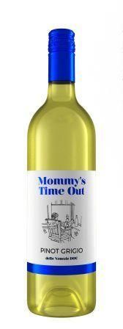
“No matter what stage you’re at when it comes to being a Mommy, it’s one of the toughest and most rewarding jobs there is. That’s why we believe Mommy deserves something special for herself now and then, with Mommy’s Time Out Wine.” says Mike Cincotta President of Selective Wine Estates, Inc.
Adults over the age of 21 should enjoy Mommy’s Time Out responsibly.
For more information on Mommy’s Time Out please visit www.mommystimeoutwine.com.
*Mommy’s Time Out is a registered trademark of Selective Wine Estates, Inc.
** For editorial samples, please contact Mike Cincotta at (973) 722-3305 or email media@mommystimeout.net **
Logo:
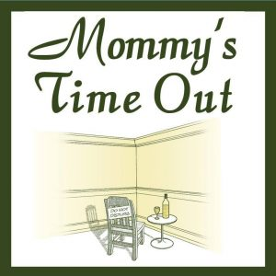
Mommy’s Time Out logo
Press release distributed via EPR Network (http://express-press-release.net/submit-press-release.php)

