Increase in Travel Booking to Kenya for the year 2021 #RestartTourism with Cruzeiro Safaris Kenya to Wildlife Safari Vacations in Kenya

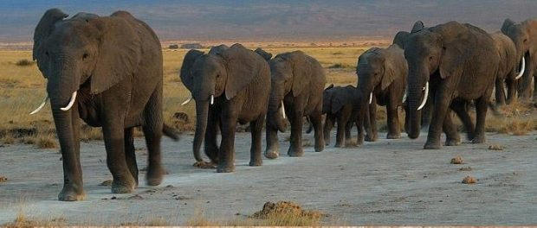
NAIROBI, Kenya, 2020-Dec-09 — /EPR Network/ — Best Year for wildlife viewing in Kenya begins with Cruzeiro Safaris Kenya.
The tourism industry is anticipated to boom the year 2021 and 2022 with expected tourism arrivals also excepted to increase rapidly. The discovery of the new COVID 19 vaccine brings a relief to the travel industry. This Boost is a godsend because tourism is one of the six economic pillars identified by the government as central in driving the economy. Kenya aims to be one of the top 10- long- haul tourist destinations in the world. Voted as one of the best Tourism Destination in the World, preferred by many travelers.
Cruzeiro Safaris Kenya is prepared to host tourists, delegates and all travelers through providing tour operator services in Kenya. Their website is confirmed to e-commerce and guests can easily access, read details and book online for Tour within Nairobi and Mombasa as well as Road Safaris and Air Safaris.
The famous Safari for 6 days to Destination Amboseli National Park, Lake Nakuru National Park and Masai Mara National Reserve with 4×4 wheel drives has gained popularity within the last minute travelers especially during this season termed as the high season. The full Package details can be found on this link .
Learn more on wildlife Safari Packages and their Online Booking Partners on https://www.cruzeiro-safaris.com
Other safaris that can be booked through Cruzeiro Safaris Kenya Include:
Four (4) Days Lake Nakuru and Masai Mara Safari
Seven (7) Photography Wildlife Safaris with Experts In 4×4 wheel Drives
Nine(9) Days Safari from Nairobi to Mombasa
Nine(9) Days Mount Kenya and Masai Mara
Three (3) Days Masai Mara Safari by Air
Seven (7) Days Serena Safaris by Air
Five (5) Days Masai Mara By Air
Two (2) Days Governors Camp Safari By Air
Three (3) Days Serena Masai Mara by Air
Seven (7) Days Singles/ Solo Travel Package by Air with Luxury Accommodation only
Three (3) Days Mara Intrepids Safari by Air
Two (2) Days Amboseli Day Trip – Stay at Amboseli Serena Lodge
If one is searching or finding things to do in Nairobi their e-commerce site has vast information and tour packages choices https://cruzeiro-safaris.com/nairobi-tours
Follow the links for book and pay options
Option 1: 6am – 11am – Nairobi National Park Morning Tour – In Safari Minivan
Option 2: 6am – 11am – Nairobi National Park Morning Tour – In 4x4wheel Drives
Option 3: 1:30pm – 6.30pm – Nairobi National Park Morning Tour Afternoon – In Safari Minivan
Option 4: 6-1pm – Nairobi National Park Tour and Giraffe Center – In 4×4 wheel Drives
Giraffe Center Tour – Various Departure Time
Lake Nakuru National Park Full Day Tour -In 4×4 wheel Drives
Lake Nakuru National Park Full Trip -In Safari Minivan
Lake Naivasha Crescent Island Tour
Amboseli National Park Tour Full Day – in Safari minivans
Cost Includes:
• Game viewing drive,
• Transport pick up and drop off from hotel / Airport
• Lunch where applicable on the package
• Entry to Giraffe center with applicable package
• Park Entry Fees in All places
• Safari Driver guide
About Cruzeiro Safaris Kenya
Cruzeiro-safaris.com is established in Kenya, incorporated in 2004. Its core business is safari packages and day tours complemented by air travel. It has a well-established wealth of experience in arranging memorable tours and safaris and has established a client base who provide with repeat business year after year. Join us on facebook, twitter and youtube. Safaris in Kenya may be tailored to the tourist taste and can extend to Tanzania and Uganda. Browse and read reviews on trip advisor page and one can also book from trip advisor link.
For further information and reservations, contact;
Claudia Kabui
Mobile : +254-(0) 722-370833 (Kenya)
Sales: + 254 (0) 710-729021 (Kenya)
Email: info@cruzeiro-safaris.com
Website: | https://www.cruzeiro-safaris.com and https://cruzeiro-safaris.com/nairobi-tours/
Logo:
Cruzeiro Safaris Kenya logo

Press release distributed via EPR Network (http://express-press-release.net/submit-press-release.php)

