Water Container Recycle Problem Solved
100% Biodegradable Container – 01.05.21
Greenup, Kentucky, U.S.A., 2021-Jan-05 — /EPR Network/ — Kentucky Pure Mineral Water comes in a 100% Biodegradable Container, so even if it DOESN’T get recycled properly, it won’t leave its mark on the earth forever the way typical plastic containers will.
Problem solved. Enough said!
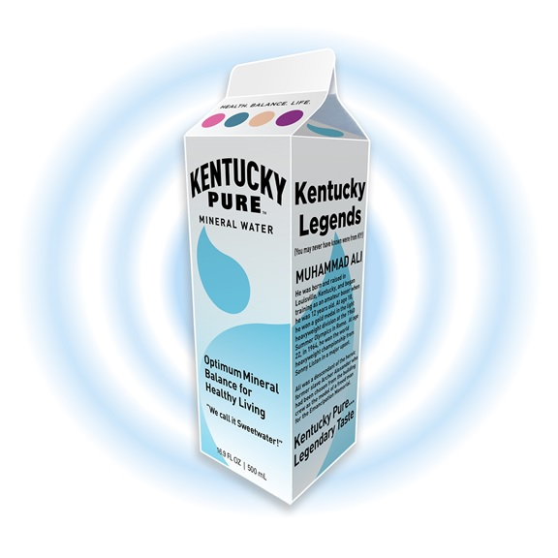
Look for Kentucky Pure Mineral Water on store shelves soon!
Media contact:
River Rock Water LLC
16387 State Route 7
Greenup Ky 41144
Press release distributed via EPR Network (http://express-press-release.net/submit-press-release.php)

