One Container of Healthy!

Greenup, Kentucky, U.S.A., 2021-Jan-08 — /EPR Network/ — Kentucky Pure Mineral Water comes naturally with all the minerals and elements needed to keep a body healthy and vital.
Sorry Doc, not today! Enough said!
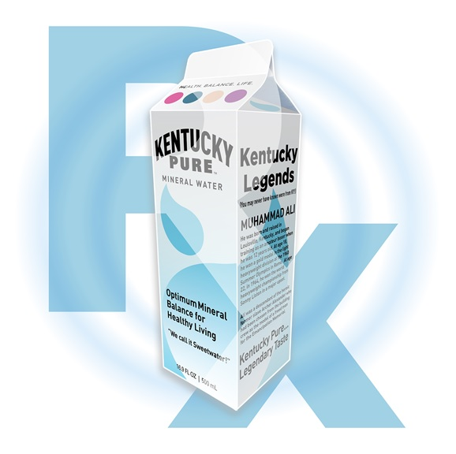
Look for Kentucky Pure Mineral Water on store shelves soon!
Media contact:
River Rock Water LLC
16387 State Route 7
Greenup Ky 41144
Press release distributed via EPR Network (http://express-press-release.net/submit-press-release.php)

