Tarps Now® Announces Expansion of Mesh Screen Tarps Offerings

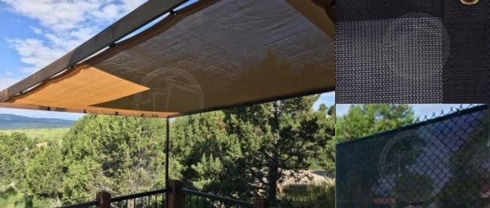

St. Joseph, Michigan, 2021-Jan-12 — /EPR Network/ — Tarps Now® is pleased to announce the roll out of new lines of Mesh Tarps frequently used as protective coverings around homes, animal habitats and other outdoor structures. Tarps Now® routinely custom manufactures protective mesh tarp coverings in a variety of mesh screen exposure ratings, weights, fabric grades and colors, that are all engineered to provide outstanding levels of protection from intense sunlight, as well as other forces of nature.
Mesh Screen Tarps are in large demand specific to applications as windscreens that offer varying levels of wind resistance, depending on the selected material and design. Applications for these new lines of Mesh Screen Tarps extend to uses in and around homes, such as patios, decks, thresholds, gazebos, pools, picnic areas, barns, animal kennels and other outdoor recreational areas.
In addition, many businesses are adopting the use of Mesh Shade Tarps to protect employees who work in areas where prolonged exposure to the elements exists such as in agricultural processing areas, animal feedlot areas, warehousing dock areas, shipping and receiving areas, and many other applications where reduction of ultraviolet radiation associated with direct exposure to intense levels of direct sunlight.
Details on the Product Expansion are as follows:
Tarps Now® Shade Products:
https://www.tarpsnow.com/mesh-shade-tarps.html
https://www.tarpsnow.com/shade-tarps-polypro-mesh-95.html 95% Exposure
https://www.tarpsnow.com/86-knitted-shade-mesh-tarps.html 86% Exposure
https://www.tarpsnow.com/polypro-mesh-shade-tarps-70.html 70% Exposure
https://www.tarpsnow.com/polypro-mesh-shade-tarps-60.html 60% Exposure
https://www.tarpsnow.com/polypro-mesh-shade-tarps-50.html 50% Exposure
https://www.tarpsnow.com/polypro-mesh-shade-tarps-50.html 40% Exposure
https://www.tarpsnow.com/specialty-tarps.html
https://www.tarpsnow.com/tarp-products.html
About Tarps Now®
Tarps Now® features an extensive online catalog of canvas tarps, poly tarps, custom tarps, vinyl tarps and industrial divider curtains. As specialists in custom canvas and vinyl tarps, they are the low-price leaders in their category. The company offers the convenience of fast, easy, online ordering as well as a knowledgeable staff to guide customers through the specification process insuring their project will be completed on time and in budget. Tarps Now® has the experience and scale to insure customer specifications are carefully followed and expectations exceeded for every project, large or small.
Media contact:
Tarps Now, Inc.
4133 M-139
St Joseph, MI 49085
888-800-1383
sales@tarpsnow.com
https://www.tarpsnow.com
Logo:
Tarps Now® logo
===
Press release distributed via EPR Network (http://express-press-release.net/submit-press-release.php)

