TIKTOK FOLLOWERS, VIEWS AND LIKES SERVICE

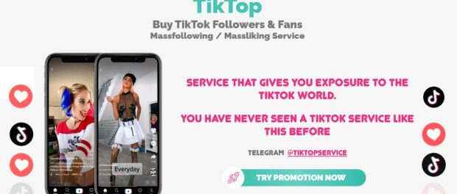
MIAMI, FL, U.S.A., 2021-Jan-15 — /EPR Network/ — Not so long ago, a new service appeared in the field of TikTok promotion. And it is this service called TikTop that has proven itself quite Well. There are several reasons for this: over the history of its existence, it has gained a good reputation and, at the same time, offers services at quite pleasant prices compared to competitors.
Let’s see why this service is effective. So, the advantages:
The service allows Users to establish contact only with active users. Visiting Tiktoks, even adding videos from time to time, does not mean being active enough (from the point of view of an entrepreneur who promotes products, services, or just maintains their own content). But the video is uploaded by active users who are fond of Instagram.
Short stories. One video lasts a very short time. As a rule, users are not very attentive to short-term content posts, so they post several videos a day. And users can quickly view them.
First of all, profiles that TikTok thinks are interesting are displayed. However, viewing such pages is also more profitable for the buyer.
Only the video displays a list of people who viewed the content. But the person will not be able to find out who visited the profile.
And, finally, it is worth emphasizing once again that this service, as a method of attracting an audience and feedback from it, is still unknown to many. Therefore, users think that the owner of the TikTok account is actually gradually gaining popularity and is interested in content that attracts other users of the social network and encourages them to perform useful actions for clients (whether it’s likes, views , comments, or subscribers to the TikTok account).
What can the client get using the TikTop service ? And yet, what will be the result after performing the technique? Let’s look at what such a client can get in the end:
New subscribers. People who have viewed clients and those who are interested in the content offered by the user will subscribe to them. Most people watch interesting new videos anyway, so they are more likely to see the clients’ content directly. It only remains to flash in their field of view (this will be done by automatically attracting views).
The increase in coverage of the page. Even those who don’t subscribe to you will increase their reach – they will visit the page, put likes, watch videos, and leave comments. In General, even if the target audience does not increase, the page activity will increase, and this is also a positive result.
Attracting an active audience that is ready for action. Customers of the Tiktok service will not receive empty subscriptions, but they will attract those who often use TikTok and receive information from It.
A user interested in the TikTop service can choose one of the categories of people according to their target audience.
TikTop service is an unobtrusive advertising method. Now everyone knows that page subscriptions are made for profit. Comprehensive promotion is always effective, so if a customer is promoting their TikTok account, promoting the channel’s telegrams, if any, will be appropriate.
Another caveat: TikTop helps not only attract a new audience, but also keep the old one in touch. For example, your page is dedicated to music. The client is subscribed to by people who are not subscribed to by the client. Thanks to TikTop, the audience constantly watches videos of these users, again, very easily and unobtrusively reminding them of themselves. The person will go to the “interesting” section and see you when it is convenient for them. In the case of other services, pages are more Intrusive, often cause a negative reaction and refusal of the account owner to which the subscription is being made.
To be fair, not everyone knows about TikTop. Mass subscriptions, thoughtless likes on several posts, empty comments that often contradict the meaning of the video-all this is striking, which can not be said about the method used by the TikTop service. Therefore, this method of promotion is still considered one of the priority, easy, unobtrusive and simple.
Media contact:
TikTop Service
contact@tiktopservice.com
tiktopservice.com

Press release distributed via EPR Network (http://express-press-release.net/submit-press-release.php)

