Curatronic Ltd. announces the new Ultra-Flash impulse PEMF device exceeding 1 Tesla

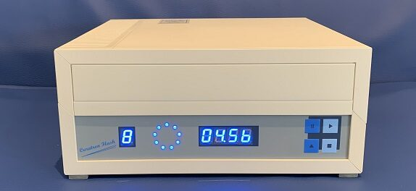
Jerusalem, Israel, 2021-Jan-28 — /EPR Network/ — The brand-new Curatron Ultra-Flash impulse PEMF machine for instantaneous pain relief.
Curatronic Ltd. announces to have started taking orders for their brand-new Curatron Ultra-Flash device completing the Curatron line of pulsed electromagnetic field therapy devices.
Curatronic Ltd. has succeeded in developing a completely service free, ultra-high intensity impulse PEMF device. The Curatron Ultra-Flash ultra-high intensity PEMF pulses are electronically controlled by high voltage solid state semiconductor game changing technology, without any need for service as required for obsolete spark gap technology.
The new Curatron Ultra-Flash has 10 internal computer-controlled programs offering a wide choice for various treatment possibilities. These built-in programs offer superior flexibility, including for use as ringer and oscillating applications of impulse PEMF.
Curatronic offers a wide range of PEMF models to choose from, according to individual needs. A wealth of information can be found on their website, both extensive technical information as well as practical applications.
Ben Philipson, CEO of Curatronic Ltd. said, “The amazing results for instantaneous pain relief have been experienced by me personally! Now that we have completed our line of impulse PEMF devices the new Curatron Ultra-Flash device excels in the ability to generate pulsed magnetic field levels exceeding the 10,000 Gauss barrier making all PEMF spark gap devices on the market obsolete. The new Ultra-Flash system is geared towards use by medical professionals and we are looking forward to start soon shipping to customers who have taken advantage of the large pre-order discount we offer.”
Further information can be found on the Curatronic website www.curatronic.com
Curatronic is the leading innovator in Pulsed Electromagnetic Field therapy. Founded in 2000, the company has clearly established itself as the undisputed leader in the field of PEMF therapy devices in 99 countries around the world.
Media contact:
Curatronic Ltd.
Ben Philipson
info@curatronic.com
Learn more www.curatronic.com

Press release distributed via EPR Network (http://express-press-release.net/submit-press-release.php)

