Rayflex discusses the benefits and advantages of industrial plastic strip curtains to your business

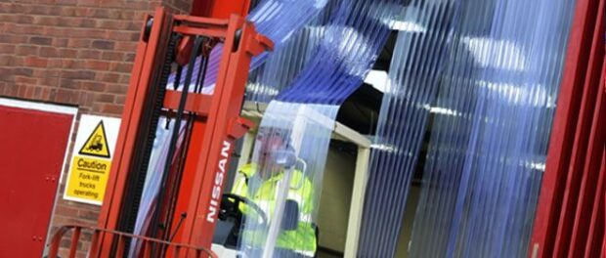
Warrington, UK, 2021-Mar-10 — /EPR Network/ — Rayflex discusses the benefits and advantages of industrial plastic strip curtains to your business.
PVC strip curtains are used across a wide range of industries due to their impressive list of features. They are economical to buy, they are easy to maintain and they do an excellent job at forming a flexible barrier that prevents energy loss. PVC Curtains can be found in use in many areas of our daily lives including at the supermarket, warehouse, distribution center, hospital, restaurants and so much more.
If an exit, entrance, or access point to a building sees constant traffic, whether personnel or vehicular, Industrial Curtains are the perfect solutions. They are as good as an open door but without allowing heat to escape or rain, wind, and dirt to enter. Plastic door curtains can be constructed from different types and weights of PVC dependent on the application. They are typically clear or tinted to that they allow for good visibility so that those using the door can see if there is an obstruction on the other side before entering.
The beauty of these Industrial Curtains is that they are great for saving energy, they maintain a room’s temperature and they are easy to install, maintain, clean, and replace and this makes them the most popular type of door barrier in the UK.
For buildings, rooms, and openings that require frequent access by pedestrians or vehicles, PVC strip curtains offer the perfect solution. Industrial Plastic Curtains are designed to form a flexible barrier across an opening. This allows easy access and yet efficiently manages the temperature of the room inside be that hot or cold. Walk-in freezers and cold stores are one such example where the PVC strip curtain comes into its own. The PVC is polar grade which means it remains flexible even when temperatures reach as low as -32 degrees.
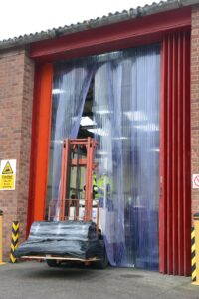
There are many advantages and benefits of Plastic strip curtains such as:
• Low cost and easy to maintain.
• Maintains the room’s ambient temperature.
• Prevents the loss of hot or cold air.
• Isolates against noise or the movement of airborne particles.
• Easy to repair or replace on a strip-by-strip basis.
• Admits light and omits rain, wind, and draughts from the workplace.
PVC strip curtains can be ordered in different sizes, weights, and grades with specialist PVC grades available such as welding bay PVC and anti-static PVC. For external curtains, the PVC tends to be of a thicker grade with more overlap to protect it from the outside elements. Internal grade plastics will be of a lighter material to aid easy passage for pedestrians.
Established in 1975, Rayflex group has specialized and led the market in the supply and manufacture of PVC strip curtains, rubber site safety products, and impact doors for both industrial and commercial use.
Rayflex Rubber Limited.
Palatine Industrial Estate, Causeway Avenue, Warrington, WA4 6QQ, UK
Phone: +44 (0)1925 638753|Email: sales@rayflexgroup.co.uk
https://www.rayflexgroup.co.uk/ https://www.pvc-strip.co.uk/
media information https://www.piranha-solutions.com/

Press release distributed via EPR Network (http://express-press-release.net/submit-press-release.php)

