Tarps Now® Announces Expansion of Mesh Tarps Division Offerings

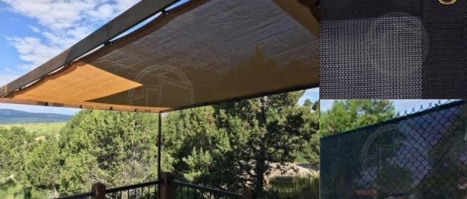
St. Joseph, Michigan, 2021-Mar-10 — /EPR Network/ — Tarps Now® is pleased to announce the expansion of new stock sized offerings of high quality, industrial grade Mesh Tarps that are used to reduce the ill effects of sustained exposure to high winds and intense levels of direct sunlight that are frequently linked to causing skin cancers in both humans and animals.
To meet the need for protective coverings around homes, gazebos, kennels, barns and other forms of outdoor animal habitats, Tarps Now® routinely offers and ever increasing assortment of protective mesh tarps with a wide range of exposure ratings, weights, fabric grades and colors.
All Mesh Tarps offered by Tarps Now® are engineered to provide long term performance, as well as outstanding levels of protection from intense sunlight, as well as other forces of nature. Exposure to the damaging effects of exposure to high winds and ultra-violet radiation are substantially reduced as a number of options exist for varying levels of both UV protection and wind resistance, depending on the selected material and design.
Applications for Tarps Now® Mesh Shade Tarps extend to uses in and around many businesses adopting the use of Mesh Tarps to protect employees who work in areas where prolonged exposure to the elements exists such as in agricultural processing areas, animal feedlot areas, warehousing dock areas, shipping and receiving areas, and many other applications. Details on these offering include, but are not limited to, the following products:
Tarps Now® Mesh Tarps:
https://www.tarpsnow.com/mesh-shade-tarps.html
https://www.tarpsnow.com/shade-tarps-polypro-mesh-95.html 95% Exposure
https://www.tarpsnow.com/86-knitted-shade-mesh-tarps.html 86% Exposure
https://www.tarpsnow.com/polypro-mesh-shade-tarps-70.html 70% Exposure
https://www.tarpsnow.com/polypro-mesh-shade-tarps-60.html 60% Exposure
https://www.tarpsnow.com/polypro-mesh-shade-tarps-50.html 50% Exposure
https://www.tarpsnow.com/polypro-mesh-shade-tarps-50.html 40% Exposure
https://www.tarpsnow.com/specialty-tarps.html
https://www.tarpsnow.com/tarp-products.html
About Tarps Now®
Tarps Now® features an extensive online catalog of canvas tarps, poly tarps, custom tarps, vinyl tarps and industrial divider curtains. As specialists in custom canvas and vinyl tarps, they are the low-price leaders in their category. The company offers the convenience of fast, easy, online ordering as well as a knowledgeable staff to guide customers through the specification process insuring their project will be completed on time and in budget. Tarps Now® has the experience and scale to insure customer specifications are carefully followed and expectations exceeded for every project, large or small.
Media contact:
Tarps Now, Inc.
4133 M-139
St Joseph, MI 49085
888-800-1383
sales@tarpsnow.com
https://www.tarpsnow.com
Logo:
Tarps Now® logo
===
Press release distributed via EPR Network (http://express-press-release.net/submit-press-release.php)

